PFC Dave Martin Bartholomew
February 9, 1949 – December 30, 1967

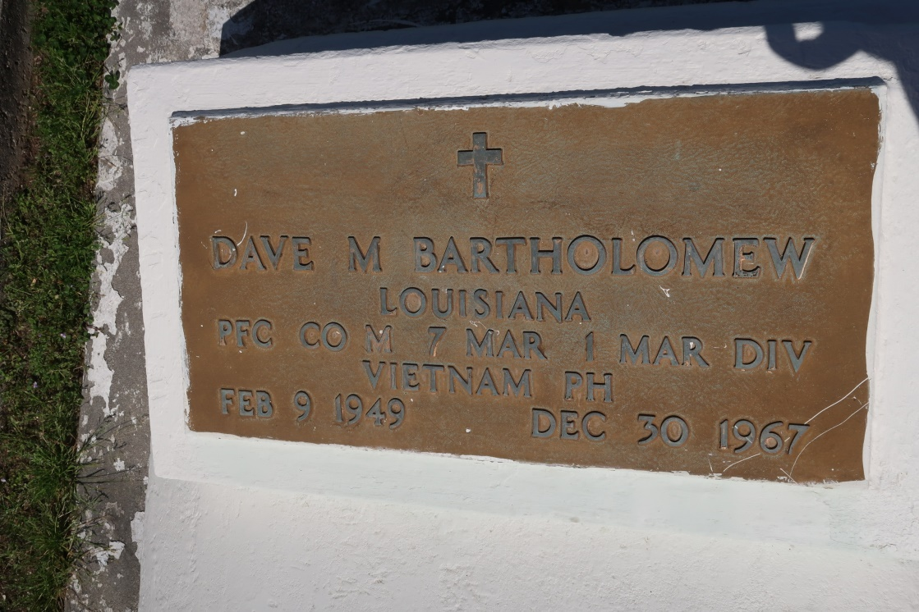
Dave, the son of John Bartholomew and Edith S. Bartholomew of Marrero LA enlisted in the US Marine Corps on July 12, 1967 in New Orleans LA. He arrived in Vietnam on December 17 and was assigned to Company M, 3d Battalion, 7th Marines, 1st MARDIV (Rein) FMF. While on combat patrol in the vicinity of Loc Phuoc hamlet in Dai Loc District PFC Bartholomew stepped on a pressure activating device which caused an AP (Anti-Personnel) mine believed to have been a 155 mm artillery round to detonate. The explosion killed the young Marine as a result of multi fragmentation wounds.
Unknown source

