Eloise (Isom) Bartholomew
September 12, 1919 - November 29, 2005

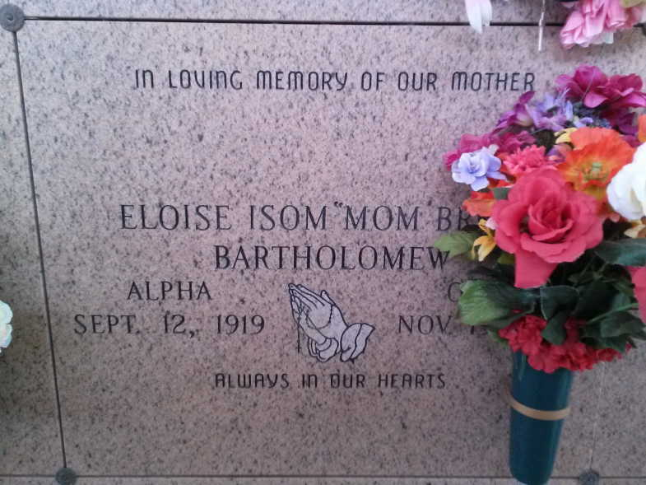
Photo by TMB

Eloise Isom Bartholomew, of Vacherie, LA. on Saturday, November 19, 2005 at 9:29 P.M. at St. Anne Rehab Center, Raceland, LA. Daughter of the late Eli and Albertha Lemieux Isom. Wife of the late Thomas Bartholomew, Sr. Mother of Joseph Sidney (Theresa), Sr., Alvin (Marie) Sr., Joseph George of Vacherie, Herman (Joyce) of Harvey, LA., Thomas of New Orleans, James Bartholomew of Donaldsonville and the late Mable B. Batiste and Milton Bartholomew, Sr. Sister of Henry and Antoine Isom and the late Agnes Franklin Tassin, Helen Nelson, Theresa Oubre, Lovenia Dumas, Gosilia Steib and Raymond Isom. Also survived by (30) grandchildren, (37) great grandchildren, (1) great great grandchild, a host of nieces, nephews, cousins and friends. Preceded in death by (1) grandchild and (1) great grandchildren. A native and resident of Vacherie, LA. Age 86 years. Relatives and friends of the family, also priest and parishoners of Our Lady of Peace Catholic Church, Members of Good Children Society, are invited to atttend a Mass of Christian Burial on Wednesday, November 23, 2005 at 11:00 A.M. From Our Lady of Peace Catholic Church, Vacherie, LA. Father Michael Miceli, celebrant. Entombment Church Mausoleum. Visitation at the church after 8:00 AM on Wednesday. The Baloney Funeral Home, L.L.C. 399 Earl Baloney Dr. Garyville, La. 70051 (985) 535-2540 In Charge of Arrangements.

Times-Picayune, New Orleans, LA
Nov. 22, 2005

