Herman J. Bartholomew
June 8, 1948 – September 26, 2011

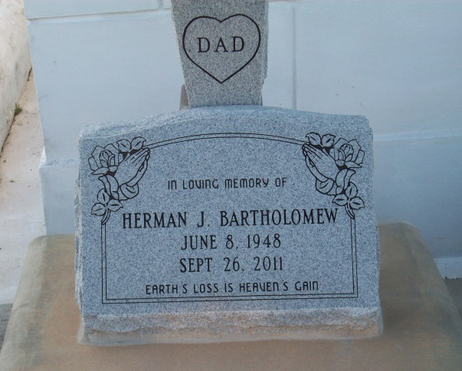
Photo on TMB

Herman Joseph Bartholomew passed away on Monday, September 26, 2011, at the age of 63, after a short and difficult battle with cancer. Loving father of Courtney Lynn Bartholomew. Son of the late Thomas Bartholomew, Sr. and Eloise Isom Bartholomew. Brother of Sidney (Theresa), Alvin (JoAnn), Thomas, and George Bartholomew of Vacherie, LA, and the late Milton and James Bartholomew and Mable Bartholomew Batiste. Also survived by former wife Joyce Weber Bartholomew, mother-in-law, Theresa Philip Weber, six godchildren, numerous aunts, uncles, nieces, nephews, cousins, other relatives and friends. Relatives and friends of the family, employees of Northrop Grumman, St. Margaret's Home Health and Hospice, St. Luke's Foundation, Mike's, Express Seafood, parishioners and employees of St. Joseph the Worker Catholic Church are invited to attend the Mass of Christian Burial on Saturday, October 1, 2011 at 11:00 a.m. at Our lady of Peace Catholic Church, 13281 LA Hwy 644, Vacherie, LA 70090. Visitation will begin at 9:00 a.m. Interment: Our Lady of Peace Cemetery. Arrangements entrusted to D.W. Rhodes Funeral Home, 1020 Virgil St., Gretna, LA.

Times-Picayune, The (New Orleans, LA) - Friday, September 30, 2011
Contributed by Jane Edson

