John Bartholomew
January 22, 1910 – November 22, 2006

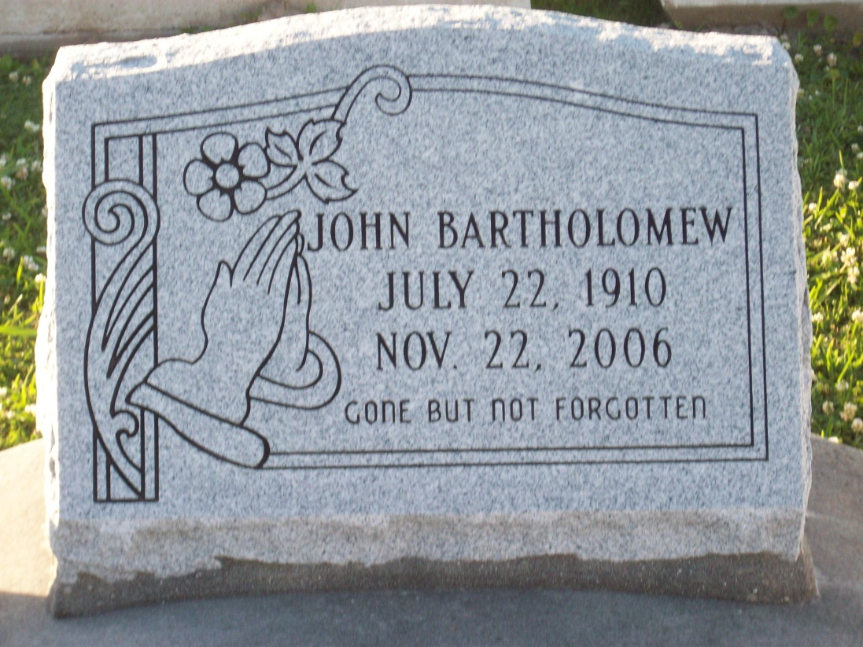
Photo by TMB

John Barthelomew Departed this life at his home on Wednesday, November 22, 2006 at 4:30 P.M. Loving and devoted husband of the late Edith Saul Barthelomew of 67 years. Father of Earnest, Arthur (of Seattle, WA), Matthew, Connie and Melba Barthelomew, Lois Dumas, Mary Love, Judith Jackson and the late PFC Dave M. Barthelomew. Son of the late John and Mary Barthelomew, Sr. Brother of the late Joseph Barthelomew, Thomas Barthelomew, Geneva Joseph, Bernadette Anderson, Amy Lewis and Almedia Phillips. Also survived by 20 grandchildren, 23 great grandchildren, 2 daughters in law, 4 brothers-in-law, 8 sisters-in-law and a host of nieces, nephews, other relatives and friends. Age 96 years. A native of Vacherie, La. and a resident of Marrero, La.

Unknown source

