Joseph Jimmie Bartholomew
September 6, 1946 – September 10, 2009

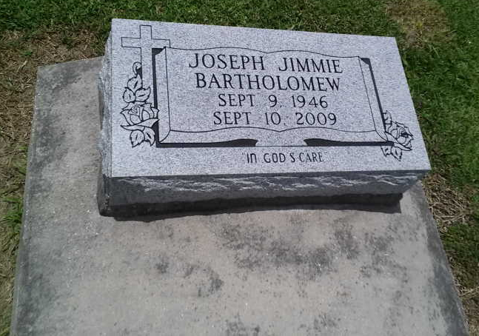
Photo by TMB

Joseph "Crackcorn" Jimmie Bartholomew, of Vacherie, LA, on Thursday, September 10, 2009 departed this life. Husband of Amanda and former husband of Wanda Bartholomew. Father of Dametrace, Tiffany, Jamie, Tameika, Lakeya, and Jonas. Brother of Sidney Sr., Herman, Alvin Sr., Joseph George, and Joseph Thomas. Survived by 8 grandchildren, aunts, uncles, nieces, nephews, cousins and friends.

Unknown source

