Joseph Sidney Bartholomew III
October 18, 1995 – February 11, 1999

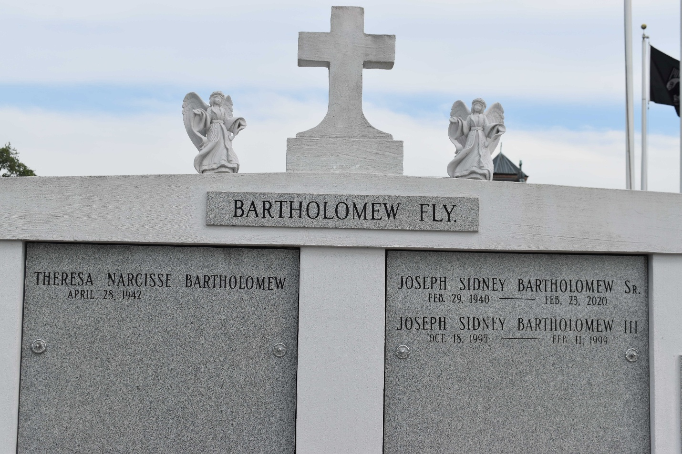
Photo by TMB

Joseph Sidney "Tre" Bartholomew III died Thursday of undetermined causes at Tulane University Medical Center. He was 3. He was born in Metairie and lived in LaPlace.
Survivors include his father, Joseph Sidney Bartholomew Jr.; his mother, Deanna Johnson Bartholomew; a sister, De'Vonnica Bartholomew; his grandparents, Kattie Lee Singleton and Theresa and Joseph Sidney Bartholomew Sr.; and his great-grandmother, Eloise Bartholomew.
A funeral will be held Monday at 11 a.m. at Israelite Baptist Church, 2192 Alexander St., Lutcher. Visitation will begin at 9 a.m. Burial will be in Our Lady of Peace Cemetery in Vacherie.

Unknown source

