Milton Bartholomew, Sr.
November 23, 1942 – October 2, 2000

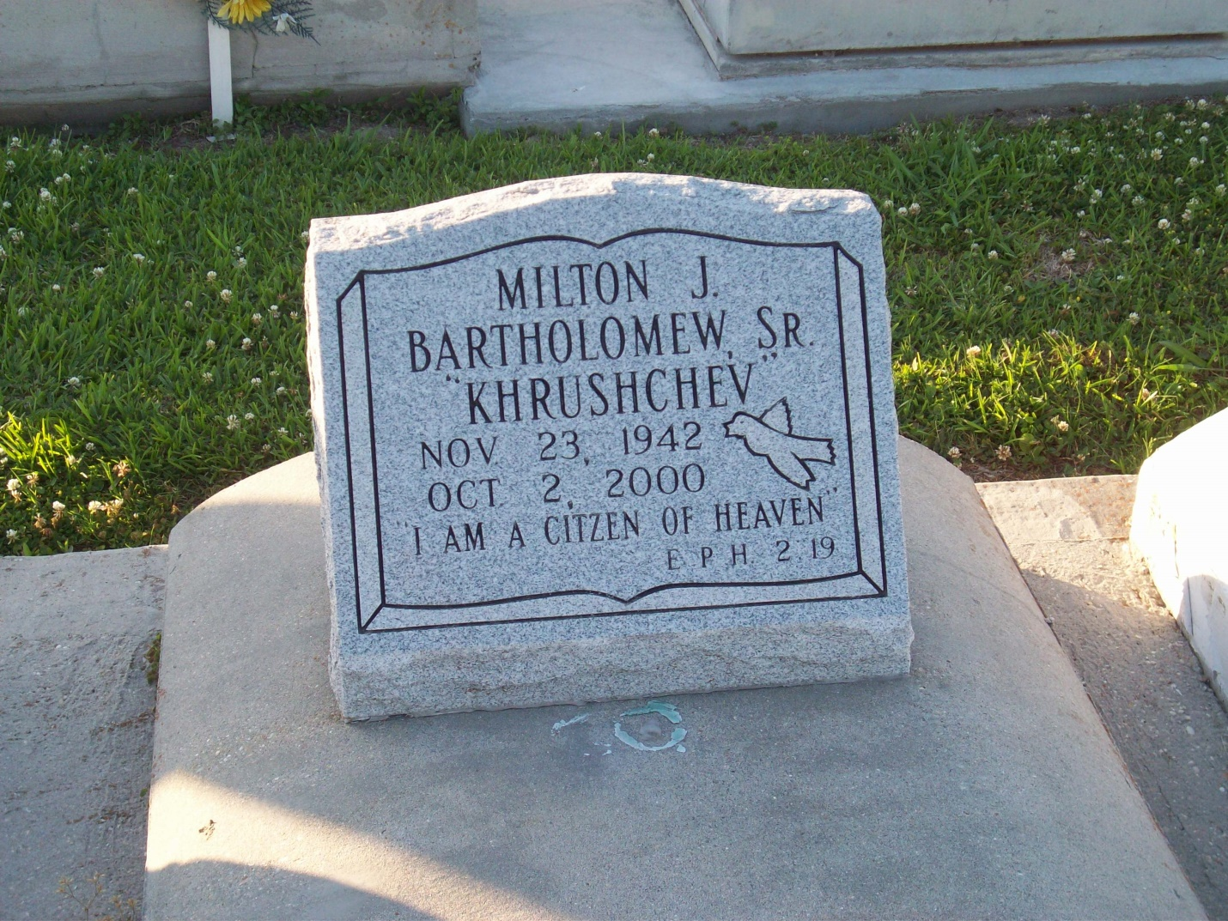
Photo by TMB

Milton "Kruschev" Bartholomew Sr., a shipfitter, died Monday of a heart attack at West Jefferson General Hospital. He was 57. Mr. Bartholomew was born in Vacherie and lived in Marrero for many years. Survivors include two sons, Sedrick Bartholomew of Thibodaux and Milton J. Bartholomew Jr.; a daughter, Shenna Bartholomew of Gretna; six brothers, Sidney, Jimmy, Alvin and George Bartholomew, all of Vacherie, Herman Bartholomew of Harvey and Thomas Bartholomew Jr.; and seven grandchildren.

Unknown source

