Davis Batiste Jr.
September 21, 1956 – December 30, 2003

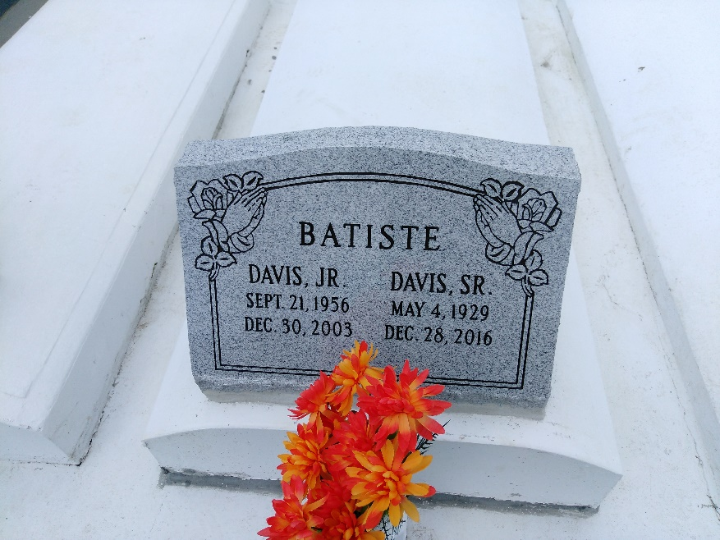
Photo by TMB

Davis Batiste Jr., a construction laborer with Avondale Shipyard, died Tuesday of pneumonia at Canon Hospice. He was 47. Mr. Batiste was a lifelong resident of New Orleans. He attended St. James High School. He was a parishioner of Our Lady of Peace Catholic Church.

Survivors include his wife, Charlene Batiste; a daughter, Shanika Batiste; his father, Davis Batiste Sr.; his stepmother, Eva Batiste; and three brothers, Charles Hayes, and Alton and Thomas Batiste.

A memorial service will be held Tuesday at 11 a.m. at Our Lady of Peace Catholic Church, Vacherie. D.W. Rhodes Funeral Home is in charge of arrangements.

Times-Picayune, The (New Orleans, LA)
Monday, January 5, 2004

