Davis Batiste, Sr.
May 4, 1929 – December 28, 2016

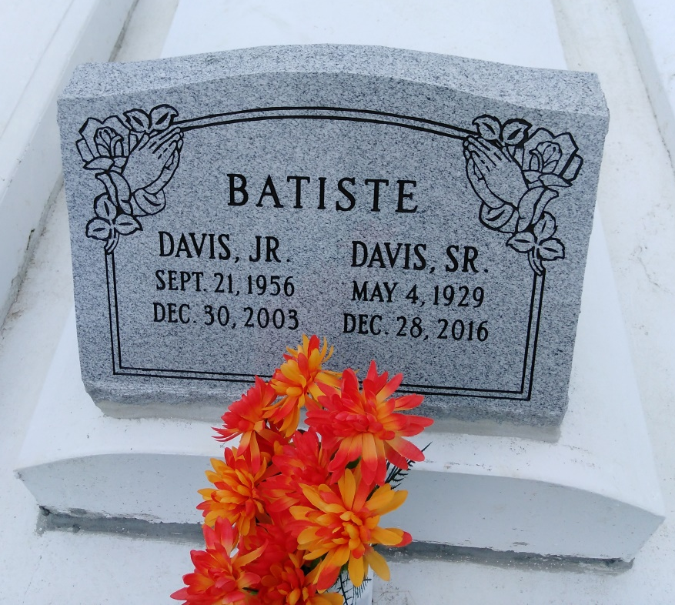
Photo by TMB

Davis (Con) Batiste a lifelong resident of Vacherie, Louisiana departed this life on Wednesday, December 28, 2016 at Thibodaux Regional Medical Center. He was employed by John Mansville in Marrero and retired from Avondale Shipyard in Avondale. He was the husband of the late Marie Ellis Batiste of Convent, LA and for the last 30 years has been married to Eva Harry Batiste. He is survived by his wife, Eva Batiste, sons, Alton (Cynthia), Thomas, stepchildren, Charlie, Vanessa, Larry, Harold, Jacqueline, Sondra and Joanette. A Mass of Christian Burial will be celebrated on Wednesday, January 4, 2017 at Our Lady of Peace Catholic Church, 13281 Highway 644, Vacherie, Louisiana at 11:00am. Visitation will begin at 9:00am. Interment: Our Lady of Peace Cemetery. Arrangements by: D.W. Rhodes Funeral Home, 3933 Washington Ave.

NOLA.com

