Emile Batiste Jr.
September 9, 1920 – February 5, 1961

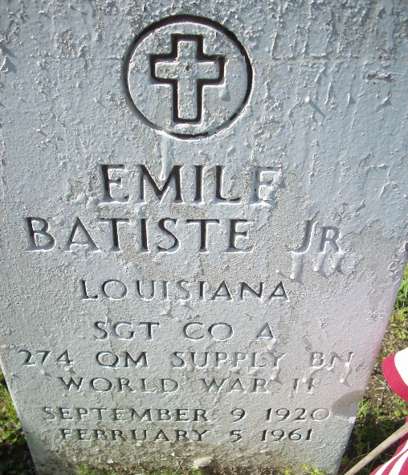
Photo by TMB

BATISTE – At the late residence, 529 Washington st., Biloxi, Miss., on Saturday, February 5, 1961, at 10:30 o’clock a.m., Emile Batiste Jr., beloved son of Mr. and Mrs. Emile Batiste Sr.; brother of Roger, Edmond, Eddie, Walter, Edwin and William Batiste and Mrs. Gladys Thompson, Mrs. Odiel Dumas and Mrs. Juanita Favorit deceased, survived by other relatives and friends. A native of Algiers, La., and a resident of Biloxi, Miss. For the past years.
Relatives and friends of the family, also local union No. 1419 I. L. A. General Longshoreman, Ladies Auxiliary Court No. 52, Ladies Sodality Sr. and Holy Name society of Holy Ghost Catholic church.
Services from Louisiana Undertaking Co, Inc., 1449 N. Claiborne Ave. on Tuesday morning, February 7, 1961 from the parlor at 8:30 o’clock a.m. Requiem Mass at Holy Ghost Catholic Church, Louisiana Ave. at Danneel Street at 9 o’clock a.m. Father S. J. Delaney, C.S.S.P., officiating. Remains will be transferred via motorcade to Vacherie, La., for interment in Our Lady of Peace Cemetery. Wake Monday, February 6, 1961, at the parlor. Louisiana Undertaking Company, Inc. in charge.

Unknown newspaper clipping

