Larry Andre Borne
November 4, 1949 – December 2, 2023

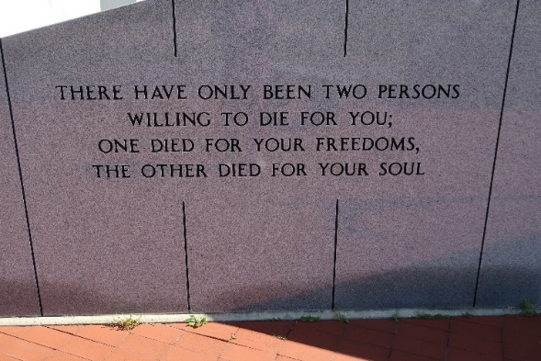

Larry Andre’ Borne, 74, died Saturday, December 2, 2023. Born November 4, 1949, he was a native of Edgard, Louisiana and resident of Vacherie, Louisiana.
A visitation will be held on Thursday, December 7, 2023 from 9:00 AM until service time at Our Lady of Peace Catholic Church. A Mass of Christian Burial will begin at 11:00 AM with burial following in the church cemetery.
He is survived by his wife of 52 years, Mary Labat Borne; daughters, Katina B. Navarre (Greg), Leanne B. Gravois (Andy); grandchildren, Kassie Gravois and Kain Gravois; sister, Sallie Rose.
He is preceded in death by his parents, Roy Borne, Jr. and Stephanie Amedee Borne; brothers, Gerald Borne, Michael Borne and Roy Borne; sisters, Audrey (V.J.) Dufrene and Patricia Cazes; father and mother-in-law, Nelson and Genevieve Labat.
He was a volunteer for the United Way and the Council on Aging. He was a member of the Knights of Columbus Council #12060. He was avid watcher of baseball and a big fan the New York Yankees.
The family would like to thank the staff of Heart of Hospice for their care.
Ordoyne Funeral Home is in charge of arrangements.

The Times Online, Houma/Thibodaux, Louisiana
December 5, 2023

