Eva W. (Harry) Batiste
July 27, 1933 – July 14, 2021

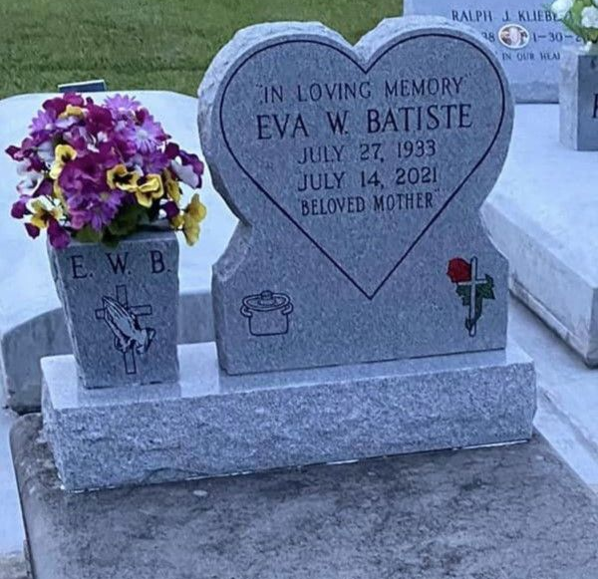
Photo by TMB

It is with great sadness that we announce the death of Eva Mae (Harry) Baptiste (sic). Born in Vacherie, Louisiana, who passed away on July 14, 2021, at the age of 87, leaving to mourn her children Vanessa Keller (Elix), Larry Woods (Charlotte), Michael Woods, Jacqueline Woods, Sondra Hines (Jason) and Joanette Allen (Douglas), 34 Grandchildren, 54 Great Grandchildren, 8 Great Great Grandchildren, 1 Sister Anita Baptiste and a host of family and friends.
She is preceded in death by her husband Davis Baptiste, Sr., daughter Nedra Woods Grogan, son Ronnie Woods, her parents Bievenue And Mary Keller Harry, her siblings Aime Chopin, Raymond, Silvain, Alfred, Jules Sr., Ernest, Milton Sr., Herbert Sr., and Esther Williams.
A funeral service was held on Saturday, July 24th, 2021, from 11:00 AM to 1:00 PM at the Our Lady of Peace Catholic Church (13281 LA Hwy 644, Vacherie, La 70090).
Funeral arrangement under the care of J.B. Rhodes Funeral Home and Cremations, Inc.

Echovita.com

