Marie Lois (Dumas) Batiste
December 8, 1932 – June 29, 2020

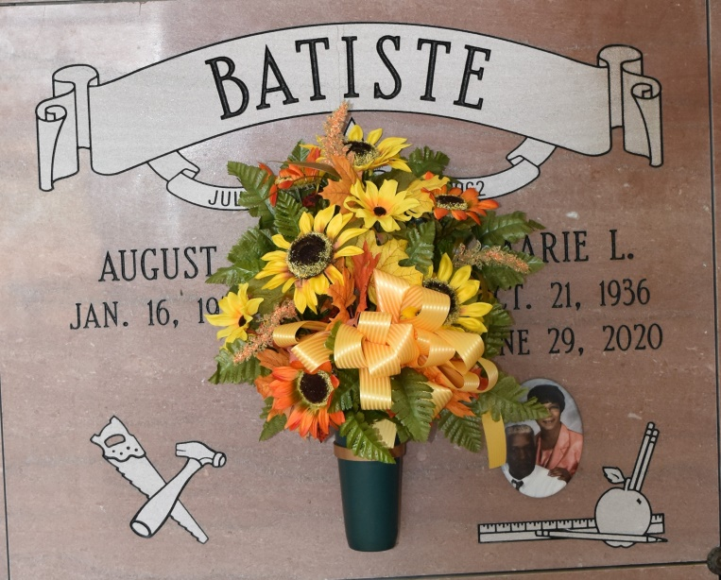

Marie Lois Dumas Batiste peacefully departed this life on Monday, June 29, 2020 surrounded by her loving family. Marie was born on October 21, 1936 to the union of the late Elphege and Eva Louis Dumas. She was a devout Catholic and a committed adorer until her health declined. Marie was a parishioner of Our Lady of Peace Catholic Church and a member of the Knights of Peter Claver Ladies Auxiliary, St. Philip Ct. #45. Marie was a graduate of Southern University and A&M College where she received a Bachelor of Arts in Elementary Education. She dutifully taught at Shell Mound and Vacherie Elementary engaging and inspiring students entrusted to her. After 35 years of service, she retired from St. James Parish School System. Marie enjoyed reading, casino trips, and spoiling her grandchildren.
Marie leaves to cherish her memories, her loving husband of 57 years, August Batiste; two daughters Mary (Brian) Dumas and Adele (Eric) Brown; four granddaughters Kaitlin Brown, Marissa Dumas, Sydney Brown, and Brianne Dumas; two great-grandsons Aaiden Dumas and August Narcisse; and one sister, Marie Helen Jeffery all of Vacherie, Louisiana. She was preceded in death by her parents, siblings Essie D. Thornton, Velma D. Calloway, Priscilla D. Gros, Cecile D. Esteen, Mildred Dumas, Eva D. James, Maude D. Lemieux, Claude, Ralph, and Bernard Dumas, a host of nieces, nephews, in-laws, godchildren, relatives, and friends.
A public viewing will be held on Tuesday, July 7, 2020 from 4 pm - 6 pm at Treasures of Life Funeral Services, 315 E. Airline Highway, Gramercy, LA 70052. Relatives and friends of the family are invited to attend the Mass of Christian burial on Wednesday, July 8, 2020 at Our Lady of Peace Catholic Church, 13281 LA-644, Vacherie, LA 70090, at 11:00 am. Father John Vu, Celebrant. Recitation of the rosary will begin at 10:15 am. Entombment to follow at Our Lady of Peace Mausoleum. Final care entrusted to Treasures of Life Funeral Services, 315 E. Airline Highway, Gramercy, LA 70052. "When someone you love becomes a memory, that memory becomes a TREASURE!" To share condolences and thoughts, and to sign guest book, please visit: www.treasurefunerals.com. Masks are required.

The Times-Picayune, New Orleans, LA
Jul. 4 to Jul. 8, 2020.

