Patrick A. Batiste
December 11, 1984 – August 18, 2010

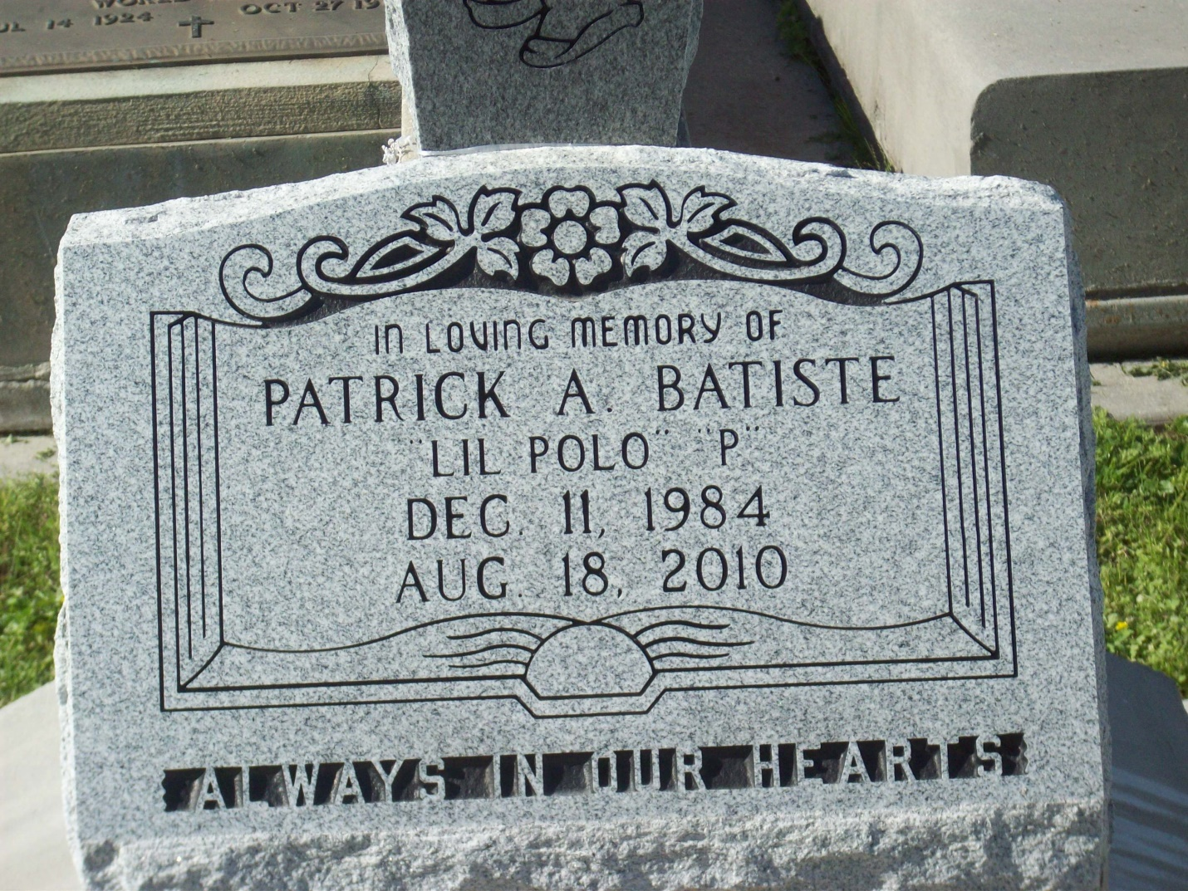
Photo by TMB

Patrick "Lil P" Batiste, a resident and native of Vacherie, died on August 18, 2010 at the age of 25. Patrick is the son of Dina Batiste of Vacherie and Patrick Sheppard of St. James. Brother of Terrika and Jordan Batiste of Vacherie. Father of Shunaja and Shuniya Batiste and Cardson Alex of Thibodaux. Devoted friend of Tammy Alex.

Unknown source

