Robert J. Batiste, Sr.
September 6, 1935 – October 29, 2008

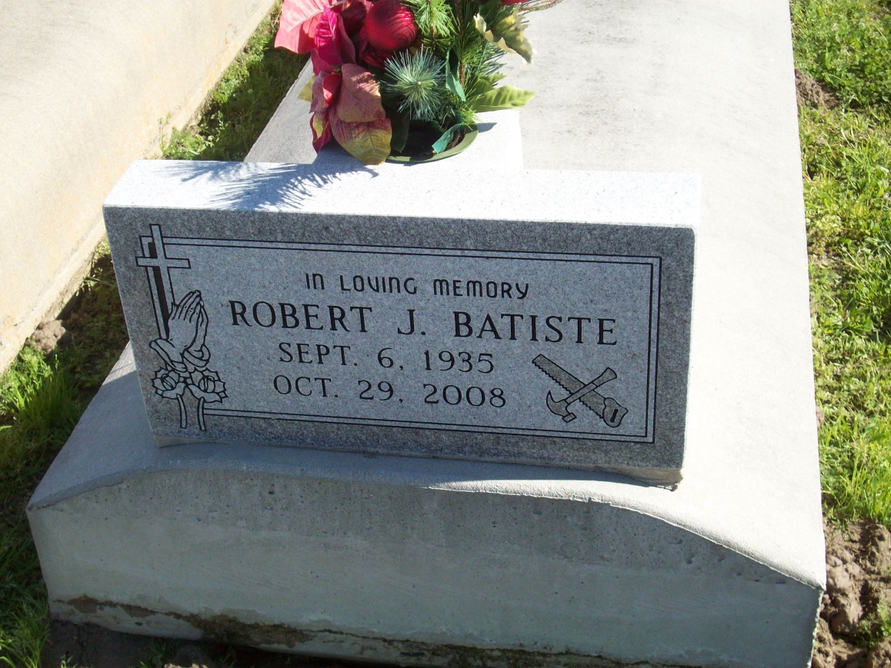
Photo by TMB

Robert (Pop) Batiste, Sr. of Vacherie, La. on Wed., Oct. 29, 2008 departed this life. Son of the late Albert and Equator Williams Batiste. Father of George Batiste, Sr., Charmaine Batiste, Bernadette Shepherd, Dina Pierre, Nicole Scott and the late Keith Anthony and Robert Batiste Jr. Brother of Norwood Batiste, Cheryl Bartholomew, Mary Lee Johnson, and the late Hayward, Earl, Charles, Iris, Albert Batiste Jr. and Norma Coco. Also survived by 14 grandchildren, 12 great-grandchildren, nieces, nephews, sons and daughters-in-law, cousins and friends. A native and resident of Vacherie. Former resident of Harvey, La., before returning back to Vacherie, La.

Unknown source

