Marie Alice (Bourgeois) Baudry
April 5, 1891 - January 14, 1962

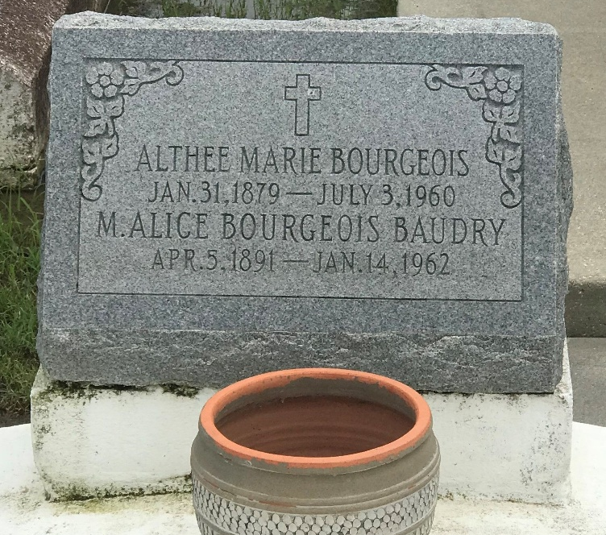
Photo by rrcar

Marie Alice Bourgeois, widow of Roger F. Baudry, died in New Orleans on Sunday, 14 Jan 1962 at age 70 years. She was a native of Vacherie, LA, and a resident of St John the Baptist Parish, LA.

Her children are Francis Baudry, Allen Baudry, Mrs. Alice Mae Himel and the late R. F. Baudry Jr.

Her parents are the late Marius V. Bourgeois and Daevina Weber. Siblings are Maurice Bourgeois and the late Althea, George, Lawrence and Fernand Bourgeois.

Funeral services were 16 Jan 1962 at Our Lady of Peace Church with interment in Our Lady of Peace Cemetery, Vacherie, LA.
The Times-Picayune, New Orleans, Louisiana
Tuesday, 16 Jan 1962, p. 2

