Anthony Chris Becnel
August 20, 1958 – February 2, 2019

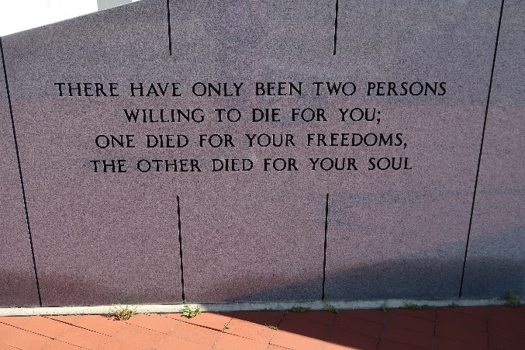

A Chris Becnel entered peacefully into heaven on Saturday, February 2, 2019 surrounded by his loving family.
Son of the late Etiennette J. Steib Becnel and Raymond G. Becnel Sr. Brother of Carolyn Becnel Millien (the late Harry Sr.), Beverly Becnel Borne, (George, Jr.), Raymond G. Becnel Jr. (the late Maisy), Susanne "Susi" Becnel Zeringue (the late Gerald), Marlene "Marty" Becnel Guillory (the late Darwin) and preceded in death by his brothers Terry Becnel and Berris Becnel. He is also survived by a host of nieces, nephews, other relatives and friends. Age 60, a native of Edgard, Louisiana and a resident of Luling, Louisiana.
Relatives and friends are invited to a Memorial Service at First Assembly of God, Des Allemands, Louisiana on Friday, February 15, 2019, at 11:30 am. Visitation from 10:30 am until service time. Inurnment in Our Lady of Peace Catholic Church Mausoleum in Vacherie, Louisiana.
In lieu of flowers, the family is requesting donations in his memory to the Louisiana Mental Health Advocacy Service, 1450 Poydras St. Suite 1105, New Orleans, LA 70112. Westside Leitz-Eagan Funeral Home, 5101 Westbank Expy., Marrero, LA in charge of arrangements.

The New Orleans Advocate, Louisiana
Feb. 12 to Feb. 15, 2019

