Albert Joseph Becnel Sr.
March 18, 1922 – June 12, 1998

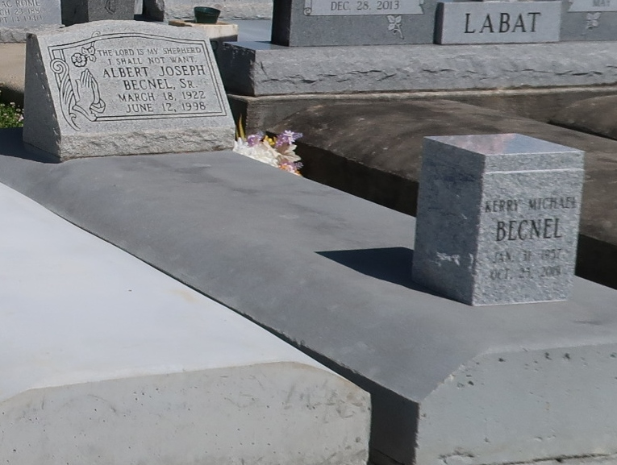

Albert J. Becnel Sr., a retired boiler engineer for a bakery, died Friday at Ochsner Foundation Hospital. He was 76. Mr. Becnel was born in White Castle and lived in New Orleans for many years. He was an Army veteran. Survivors include his wife, Ruby Haydel Becnel; two sons, Kerry and Albert Becnel Jr.; three daughters, Gail Becnel Williams, Michelle Becnel Davis and Ursula Becnel Brent; and seven grandchildren. A Mass will be said Wednesday at 10 a.m. at Our Lady of Peace Catholic Church in Vacherie. Visitation will begin Wednesday at 9 a.m. Burial will be in the church cemetery. Robottom Mortuary is in charge of arrangements.
Times Picayune, New Orleans, LA
June 16, 1998

