Alice (Falgoust) Becnel
November 9, 1919 – June 4, 2020

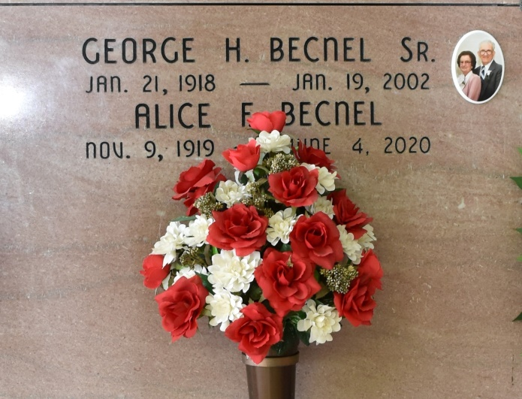

Alice Falgoust Becnel, 100, a native and resident of Vacherie, died at 1:10 p.m. on Thursday, June 4, 2020.
Visitation from 8 a.m. to 10 a.m. at Thibodaux Funeral Home on Wednesday, June 10, 2020. Mass of Christian Burial will be celebrated at 11 a.m. at Our Lady of Peace Catholic Church, followed by burial in the church cemetery.
She is survived by two sons, Ralph Becnel (Henrietta) and George Becnel Jr.; one daughter, Cathleen Becnel Richard (Russell); five grandchildren, Ronnie Becnel (Juanita), Rhonda Routier (Louis III), Angie Braud, Aimee McKenzie (Jimmy), and Nicole Wiley (Rick); five great-grandchildren, Louis Routier IV, Morgan Braud, Reece Wiley, Ryan Wiley, and McKenzie Wiley; four step-grandchildren, Brian Becnel (Monique), Cathy Gee (Michael), Allen Becnel (Nicole) and Tammy Naul (David); numerous step-great-grandchildren; one sister, Earline Becnel; and one sister-in-law, Julia Falgoust.
She was preceded in death by her husband, George Harold Becnel Sr.; her parents, Charles "Chally" Falgoust Jr. and Regina Kliebert Falgoust; siblings, Alicia Falgoust, Maurice Falgoust (Odile), Evariste Falgoust, Sedonia Falgoust, Louis Falgoust (Angelina), Norma Falgoust (Edward), Landreaux Falgoust (Daisy), Velma Delatte (Jules), Olibert Falgoust, Elizabeth Falgoust, and Horace Falgoust; a brother-in-law, Floyd Becnel; and one great-grandson, Benton Michael Routier.
Alice was a devoted wife and loving mother, grandmother, and great-grandmother. She would do anything for anyone. She is known for constantly being seen in her yard planting her beautiful flowers all around her house. She was an amazing gardener who could make anything grow. Any vegetables she gave to family and friends were cleaned and ready to cook. She was a gifted seamstress whose work was so pristine it was hard to tell if the garment was right side in or not. She was a magnificent cook noted for her special dishes like her "blue bowl" gravy, crawfish bisque, and gallette du potat, and her sweets like divinity fudge.
In lieu of flowers, please make donations to Bayou Region Alzheimer's Services, 169 Ontario Street, Houma, LA 70364. The family would like to thank the nurses and staff of Thibodaux Healthcare for their outstanding care and compassion. Thibodaux Funeral Home is in charge of the arrangements.

Houma Today, Terrebonne Parish, LA
Jun. 7 to Jun. 8, 2020.

