Aristide Joseph Becnel Jr.
January 1, 1930 – July 23, 2012

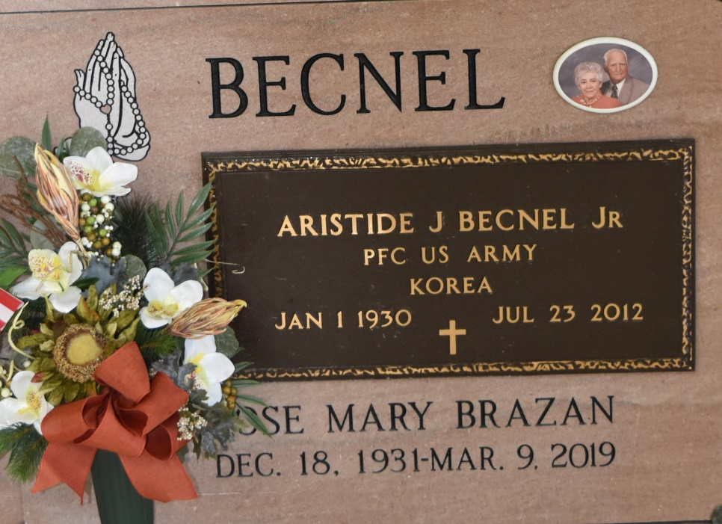

Died at 10:50 p.m. Thursday at St. Joseph Hospital in Thibodaux. He was 72, a native and resident of Vacherie. Body at Our Lady of Peace Rectory in Vacherie with visiting from 7:30 a.m. to 9:50 a.m. Saturday. Religious services at Our Lady of Peace Catholic Church in Vacherie at 10 a.m. Saturday, conducted by the Rev. Thomas Allain. Burial in the church cemetery. He is survived by his wife, Mrs. Armanda Rome Becnel of Vacherie; four sons, Sidney, Glovlance, Aristide Jr. and Lawrence Becnel; five daughters, Mrs. Cecile Castleman, Mrs. Stella Todaro, Mrs. Theresa Lomonaco, Mrs. Sherry Folse and Mrs. Dorothy Rougee; four sisters, Mrs. Felicie Reulet, Mrs. Gertrude St. Pierre, Yolande Becnel and Mrs. Margaret Torres; three brothers, Felix, Harris and Stanislaus Becnel; 30 grandchildren; and 16 great-granchildren. He was preceded in death by his father, Benjamin Becnel Sr.; his mother, Elise Stein; and a brother, Benjamin Becnel Jr. Arrangement by Landry-Caballero-Montz Funeral Home of Donaldsonville.
Unknown newspaper clipping

