Armanza (Rome) Becnel
1898 – November 1, 1990

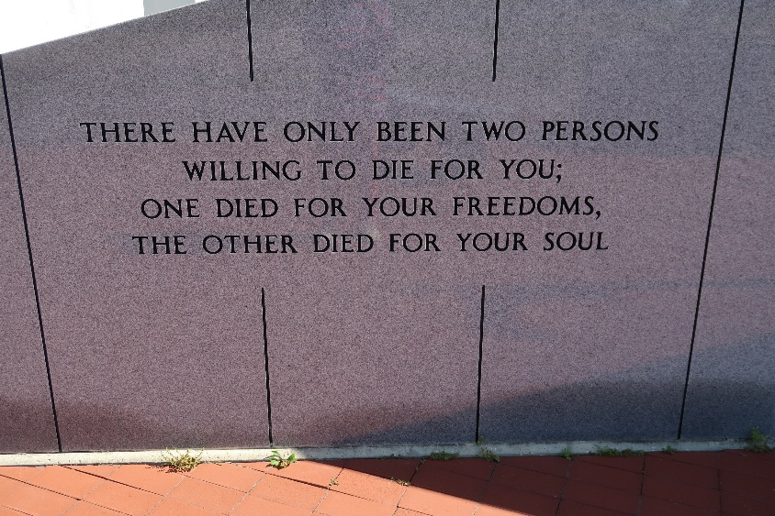

Armanza Rome Becnel, in Vacherie on Thursday, November 1, 1990, at 9:00 p.m.
Wife of the late Aristile (sic) Becnel. Daughter of the late Rudolph and Zulma Simon Rome. Mother of Sidney, Glovelance, Lawrence and Aristile Becnel, Jr., Shirley Folse and Dorothy Rougee, all of Vacherie, Cecile Castleman and Theresa Lomonaco of Marrero and Stell Todaro of Bridge City, La. Sister of Solange Boudreaux, Mamie Rome and Eldwood Rome of Harvey, La. and the late Sidonia Stein, Armance Hebert, Orelia Laga, Olday, Rudolph, Agney and Lawrence Rome. Also survived by 30 grandchildren and 52 great-grand-children and 6 great-great-grandchildren. A native and resident of Vacherie. Age 92.
Relatives and friends of the family are invited to attend the Mass of Christian Burial at Our Lady of Peace Catholic Church, Vacherie on Saturday, November 3, 1990, at 11:00 a.m. Interment in Church Cemetery. Visitation at Our Lady of Peace Catholic Church from 8:00 a.m. until funeral time Saturday. Arrangement by Ourso Funeral Home, Donaldsonville.

Unknown newspaper clipping

