Audrey (Hymel) Becnel
March 4, 1935 – October 15, 2022

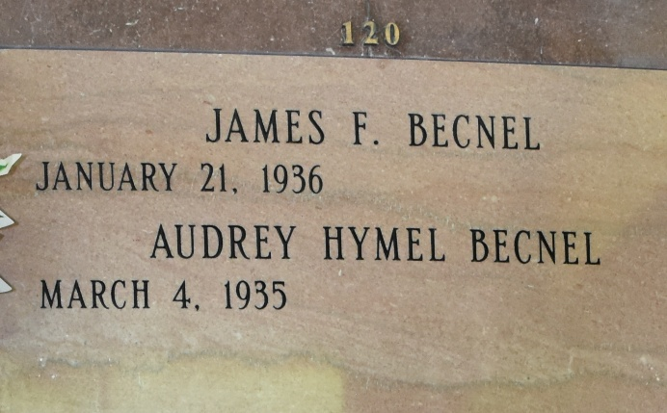

Audrey Hymel Becnel, 87, a native of St. James and former resident of New Orleans for 40 years, passed away peacefully at her home in Vacherie, on Saturday, October 15, 2022.
Audrey is survived by her loving husband of 64 years, James Becnel; sisters, Carlyn (AJ) Kliebert, Jane Rivere, Janet Ponson; sisters-in-law, Grace Hymel, Teen Hymel and Janice Hymel; brother-in-law, Jack Bourgeois; and numerous nieces and nephews.
She was preceded in death by her parents, Jules and Lucella Hymel; brothers, Kelsey, Eddie, Warren and Herman "T-Boy" Hymel; sister, Sylvia Bourgeois and brother-in-law, Carroll Ponson.
While living in New Orleans, Audrey was employed as an accountant for Bemis Bag Company for 25 years and Stewart Enterprise for 10 years. She enjoyed shopping, traveling and spending time with her family and friends. She was always willing to lend a helping hand and devoted many weekends caring for her family in need. Audrey will be deeply missed by all those who knew and loved her.
The family would like to extend their appreciation to her loving and dedicated caregivers and St. Catherine's Hospice.
Family and friends are invited to attend the Mass of Christian Burial at Our Lady of Peace Catholic Church, 13281 Hwy 644, Vacherie on Wednesday, October 19, 2022 at 11am. Visitation will be from 8:30am until funeral mass. Burial will follow in church cemetery. Ourso Funeral Home, Donaldsonville, in charge of services.

The Times-Picayune, New Orleans, Louisiana
Oct. 17, 2022

