Betty (Nicholas) Becnel
September 3, 1931 – January 25, 2014

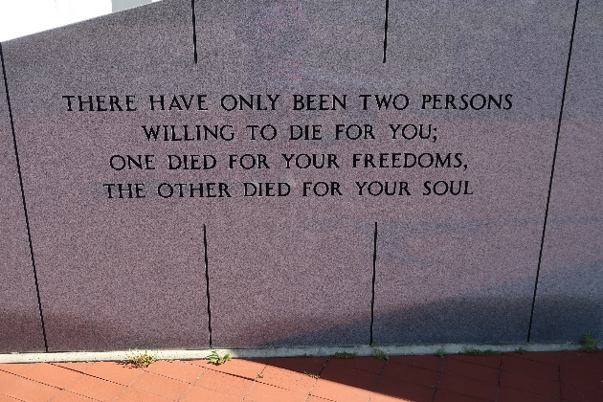

Betty Becnel, 82, passed away on Saturday, Jan. 25, 2014, at her residence.
Visitation will be from 9 a.m. until funeral time Monday at Our Lady of Peace Catholic Church in Vacherie. A Mass of Christian burial will be at 11 a.m. Monday at the church, with burial in the church cemetery.
She is survived by her husband of 65 years, Patrick Becnel; daughters, Sylvia Landry and husband, Keith, Hilda Kraemer and husband, Selves, Linda Peterson and husband, Kenny, and Marlene Baye and husband, Luke; 16 grandchildren; 39 great-grandchildren; and 14 great-great-grandchildren.
She was preceded in death by her parents, Elize Larousse and Sidney Nicholas; brother, Hilton Nicholas; sister, Lucy Reulet; and grandsons, Nicholas Morvant and Matthew Falgoust.
She was a homemaker and sold Avon for 30 years. She was loved by many and will be missed by all for eternity.
Thibodaux Funeral Home is in charge of arrangements.

Houma Today, Terrebonne Parish, Louisiana
Jan. 25 to Jan. 27, 2014

