Clifford J. Becnel Jr.
June 5, 1932 – December 10, 2000

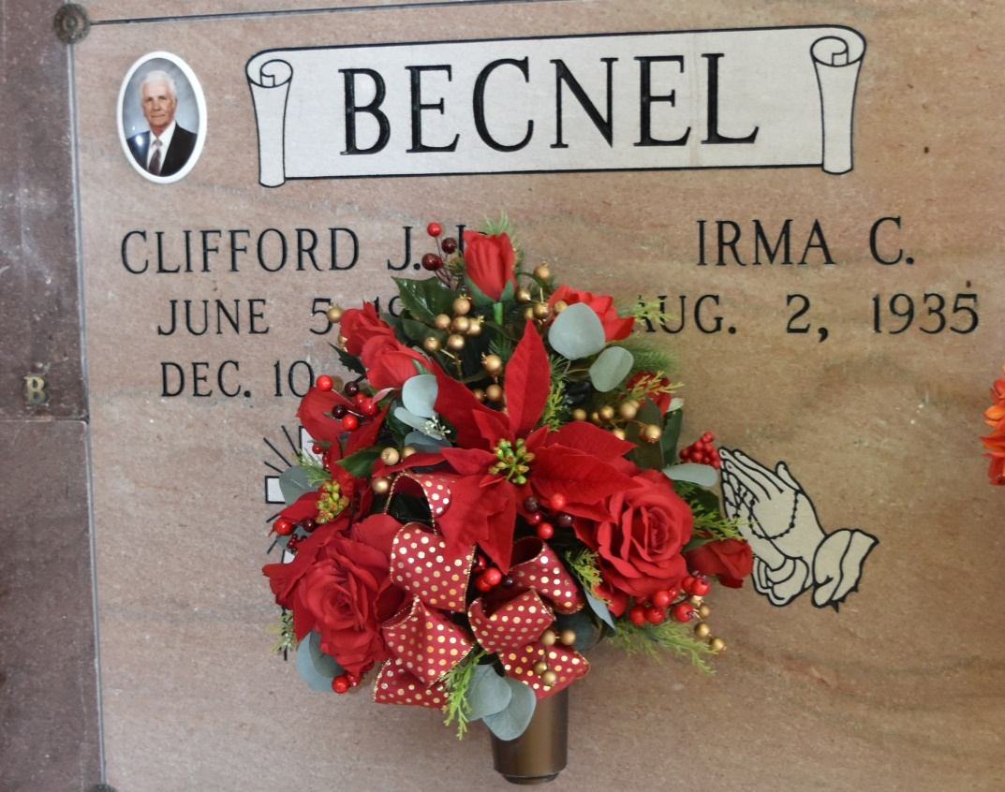

SOUTH VACHERIE - Clifford J. Becnel Jr., 68, a native and resident of Vacherie, died Dec. 10. He was the husband of Irma Cortez Becnel and father of Kenneth and Karl Becnel. He was also the son of the late Clifford Sr. and Henrietta S. Becnel and brother of Marie Steib and the late Carol and Steven Becnel. He is also survived by four grandchildren. Services were Dec. 12 at Our Lady of Peace Catholic Church, South Vacherie, with interment at the church cemetery.
L'Observateur, LaPlace, LA
December 2000

