Daniel Joseph Becnel
July 8, 1936 – June 17, 2008

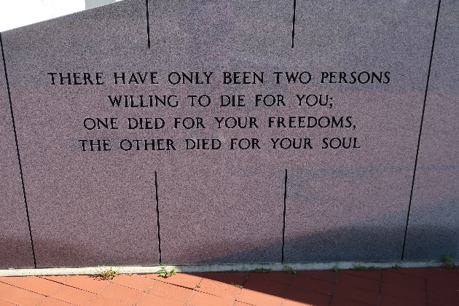

Daniel Joseph Becnel, 71, a native and resident of Vacherie, was a God loving man, died at 1:52 p.m. Tuesday, June 17, 2008.
Visitation will be from 5 to 9 p.m. today at Thibodaux Funeral Home and from 9 a.m. to funeral time Friday at Our Lady of Peace Catholic Church in Vacherie. Mass will be at 11 a.m. Friday at the church, with burial in the church cemetery.
He is survived by his wife of 50 years, Velma Hotard Becnel; four children, Sarah Becnel Mahler and husband, Ricky, Lori Becnel Cortez and husband, Leo Jr., Timothy Becnel and Billy Becnel and wife, Laura; six grandchildren, Scotty Mahler and wife, Marcy, Amber Becnel, Seth Becnel, Britney Becnel, Layne Becnel and Sydney Becnel; one brother, Lloyd Becnel; and one sister, Lucie May Falgoust.
He was preceded in death by his parents, Pete and Net Becnel. He was a U.S. Army veteran where he served two terms. He was employed at Avondale Shipyard for more than 10 years and at Kaiser Aluminum where he retired. He was a parishioner of Our Lady of Peace Catholic Church. He will be remembered by everyone as an avid fisherman and carpenter, who loved to make jokes and go to the camp.
Thibodaux Funeral Home is in charge of arrangements.

Houma Today, Terrebonne Parish, Louisiana
June 19, 2008

