Earline Anne (Falgoust) Becnel
April 19, 1929 – October 2, 2025

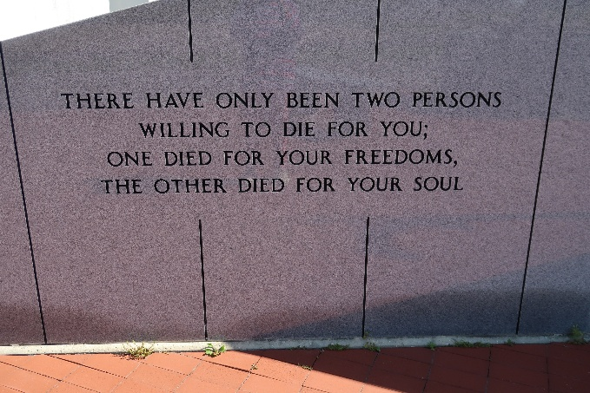

Earline Anne Becnel, 96, a native and resident of Vacherie, Louisiana passed away on October 2, 2025.
A visitation will be held in her honor on Saturday, October 11, 2025 at Our Lady of Peace Catholic Church, Vacherie, Louisiana from 8:30 am until the Mass of Christian Burial at 11:00 am. The burial will follow in Our Lady of Peace Cemetery, Vacherie, Louisiana.
She is survived by her children, Floyd Becnel, Jr (Donna Thibodeaux Becnel), Edward Becnel (Lorili Rose Becnel); Curtis Becnel (Vanessa Matherne Becnel), Jacqueline "Jackie" Becnel Ockmond (Lynn Granier), and Rose Becnel Schexnayder (Timothy); daughter-in-law, Janet Hebert Becnel; and sister-in-law, Julia Falgoust.
Earline is also survived by twelve grandchildren, Anne "Annie" Becnel, Brennon Becnel, Christie (Thomas) Granier, Cathy (Andrew) Duplantis, Jonathon Becnel (Nicole Fanguy), Claudia (Jared) Martin, Leanna (James) Cupit, Ellie (Harris) Nassar, Joshua (Ashley) Becnel, Michelle (Brent) Faucheaux, Jordan Ockmond, Jeri-Anne (Nicholas) Griffin. She is survived by 21 great-grandchildren, Alexis Steib, Brayden and Brody Granier, Andre' and Ava Duplantis, Jonathon Schexnayder, MacKenzie Becnel, Christian, Collin and Kate Martin, Grace and Colt Bergeron, John Allen Cupit, Harris, Jr and Isabelle Nassar, Callie and Natalie Becnel, Charley and Gabe Faucheaux, Sophie and Aiden Griffin.
Earline was preceded in death by her husband, Floyd "Bosco" Becnel, Sr; son, James Conrad "Jimmy" Becnel; and grandson, Eric Michael Becnel; parents, Charles "Chally" Falgoust and Regina Kliebert Falgoust; siblings, Alicia, Evariste, Sidonie, Olibert, Elizabeth, and Horace Falgoust; Maurice (Odile) Falgoust; Louis (Angelina) Falgoust; Norma (Edward) Falgoust; Landreaux (Daisy) Falgoust; Velma (Jules) Delatte; August Falgoust; and Alice (George) Becnel.
The family would like to thank Dr. M. Dirk Ory for his years of care for her, the staff of Haydel Memorial Hospice, especially nurse Patti Voss for guiding us through her transition, and caregivers Kim Williams and Janelle Ordoyne.

Thibodaux Funeral Home, Inc., Terrebonne Parish, Louisiana

