Elmo Joseph Becnel Sr.
August 9, 1921 – May 21, 2005

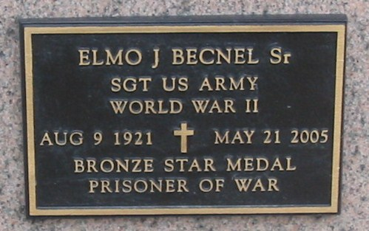
Photo by Bobby

Becnel Sr., Elmo Joseph - Born Aug. 9, 1921, he was entrusted to God's loving care Saturday, May 21, 2005, in Houma. Elmo, 83, was a resident of Vacherie, a one-time resident of Garyville, and a retired school bus driver for St. James Parish School Board. Mr. Becnel was a U.S. Army veteran, having served in World War II in the European Theater. He was also a prisoner of war.
Visitation will be held at Our Lady Queen of Peace Catholic Church in Vacherie Tuesday, May 24, from 8 a.m. until Mass of Christian Burial at 11 a.m., celebrated by the Rev. Michael Miceli. Entombment in the church mausoleum.
He is survived by a son and daughter-in-law, Elmo Joseph Becnel Jr. and Susie Becnel; two daughters and sons-in-laws, Bonita Becnel Bush and Paul Bush and Georgette Becnel Guillot and Michael Guillot Sr.; grandchildren, Bonnie Jean Bush, Michael Guillot Jr. and wife Tiffany Becnel Guillot, Jeana Becnel, Joseph Guillot, Beth Becnel and Amy Becnel; and a great-granddaughter, Jaice Michael Guillot. Mr. Elmo is also survived by his siblings, Floyd Becnel Sr., Mariette B. Becnel and Virgie Becnel Folse, all of Vacherie, Jeanne Becnel Gregoire of Garyville, and Rose Mary Becnel Gravois of Grand Point.
He was preceded in death by his wife, Mary Alice Labat Becnel; and parents, Edward Becnel and Corestile Stein Becnel. Ourso Funeral Home, Donaldsonville, is in charge of arrangements.

The Advocate, Baton Rouge, LA
May 22, 2005.

