Elodie (Ockmond) Becnel
February 18, 1908 – March 16, 1997

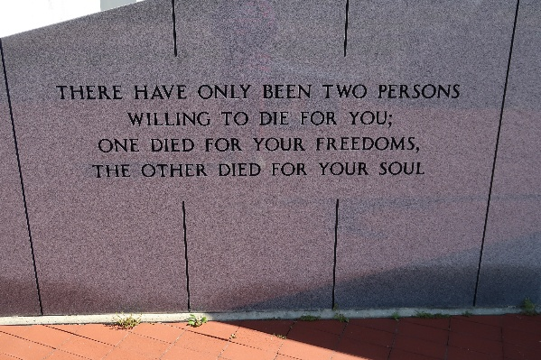

A native and resident of Vacherie, she died at 4:35 a.m. Sunday, March 16, 1997, in Vacherie. She was 89.
Visiting was at Our Lady of Peace Catholic Church Hall, Vacherie, 5 p.m. to 10 p.m. Monday, Visiting at the church was 8 a.m. until Mass of Christian Burial at 11 a.m. Tuesday, celebrated by the Rev. Clarence Waguespack. Entombment in church mausoleum.
Survived by six daughters and sons-in-law, Madeline and J.T. Oubre, Agnes and Roland Oubre and Mary and Lois Matherne, all of Vacherie, Maria and Shelby Percle, Choupic, Elaine and Wallace Naquin, Thibodaux, and Rosalyn and Lionel "Bozo" Arsement, Lockport; three sons and daughters-in-law, John Jr. and Janelle Becnel, Thibodaux, and Onezime "Nip" and Pamela Becnel and Robert "Bobby" and Barbara Becnel, all of Vacherie; a sister, Theolaine O. Tregre, Vacherie; a brother, Lucien Ockmond, Vacherie; 33 grandchildren, 61 great-grandchildren and five great-great-grandchildren.
Preceded in death by husband, John Becnel, Sr.; parents, Onezime and Olympe Oubre Ockmond; two daughters, Marjorie Chapoton and Susan Becnel; a grandchild, three great-grandchildren, and a great-great-grand-child; two sisters, Lucille O. Brazan Derocher and Lucette O. Dempster; and three brothers, Charles, Oress and Horace Ockmond. Ourso Funeral Home, Donaldsonville, in charge of arrangements.

Vacherie Enterprise, St. James Parish, Louisiana
March 19, 1997

