Etiennette Jeanne (Steib) Becnel
June 24, 1920 – June 19, 2005

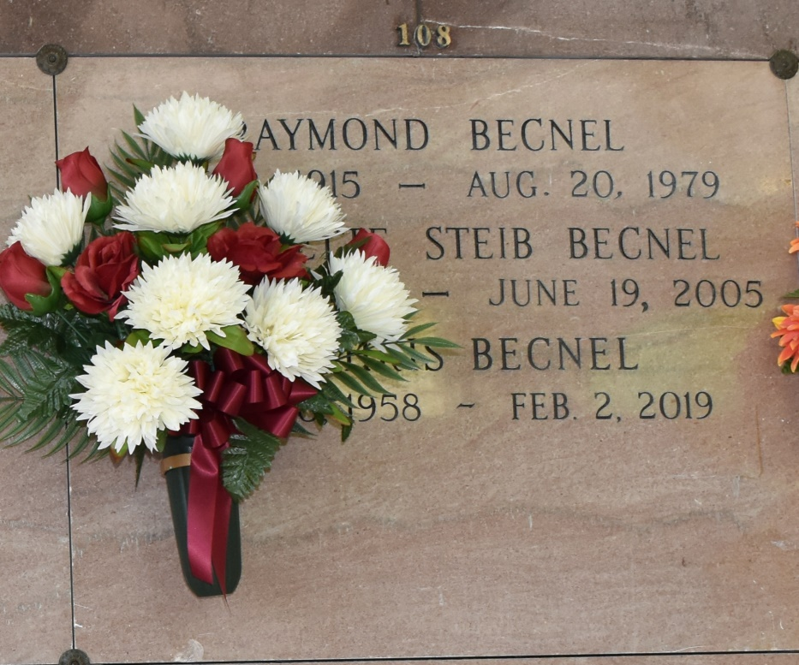

LULING - Etiennette "Net" Jeanne Steib Becnel, 84, a native of Vacherie and a resident of Luling, died June 19. She was the wife of the late Raymond G. Becnel Sr. She is survived by her children Terry Becnel, Raymond (late Maisy) Becnel, Chris Becnel, Carolyn (Harry) Millien, Beverly (George) Borne, Susanne (Gerald) Zeringue and Marlene (late Darwin) Guillory. She is also survived by 14 grandchildren, 20 great-grandchildren and two great great-grandchildren. She was preceded in death by her parents Etienne and Elizabeth Falgout Steib, siblings Berris, Rene, Adolph, Albert Steib and Josephine Reulet, granddaughter Kaylie Barras and great great-grandson Colby Falcon. Services will be held today at 11 a.m. at Our Lady of Peace Catholic Church, Vacherie, with interment in the church cemetery. Falgout Funeral Home is in charge of arrangements. Visitation at the church begins at 9 a.m.
L'Observateur (La Place, LA) - Wednesday, June 22, 2005
Contributed by Jane Edson

