Gaston Joseph Becnel
April 5, 1923 – April 25, 2010

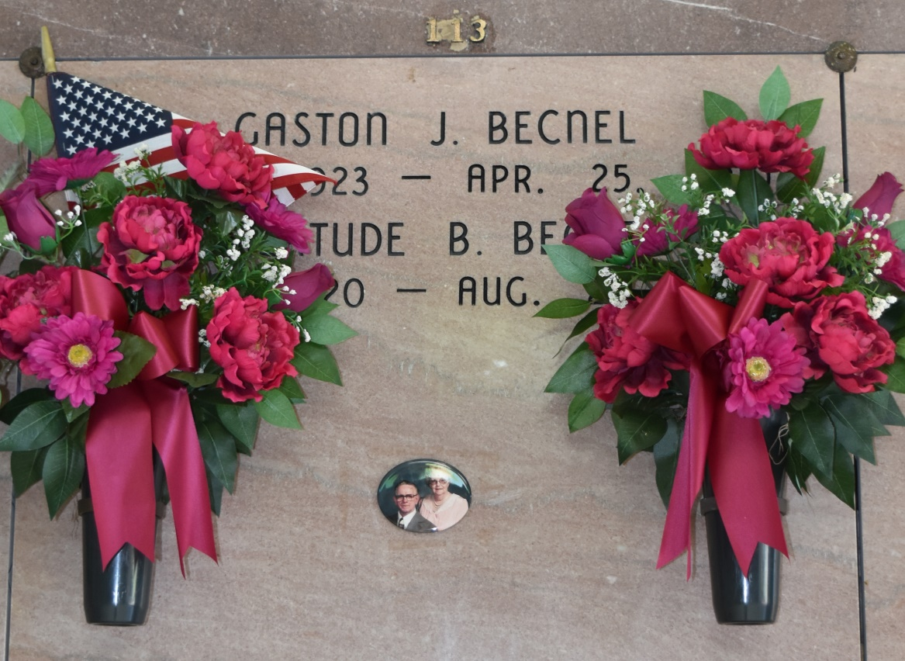

Gaston J. Becnel, 87, a native and resident of Vacherie, died Sunday, April 25, 2010. Visitation will be from 8 a.m. to funeral time Thursday at Our Lady of Peace in Vacherie. Mass will be 11 a.m. to funeral time Thursday at the church, with burial in the church cemetery. He is survived by three stepdaughters, Betty L. Martinez and husband, Gordon, Mary L. Guedry and husband, Julius, and Bernice L. Legendre and husband, Michael Jr.; nine step-grandchildren; 17 step-great-grandchildren; three step-great-great-grandchildren; one sister, Therese B. Reulet and husband, George; and numerous nieces and nephews. He was preceded in death by his loving wife, Gertrude B. Becnel; his father, Henry Samuel Becnel; his mother, Clemence Folse Becnel; one sister, Cecile Becnel Amedee; and four brothers, Samuel Henry Becnel, Joseph Guy Becnel, Charles Stanley Becnel and Maurice Roy Becnel. Thibodaux Funeral Home is in charge of arrangements.
Unknown source

