George Harold Becnel Sr.
January 21, 1918 – January 19, 2002

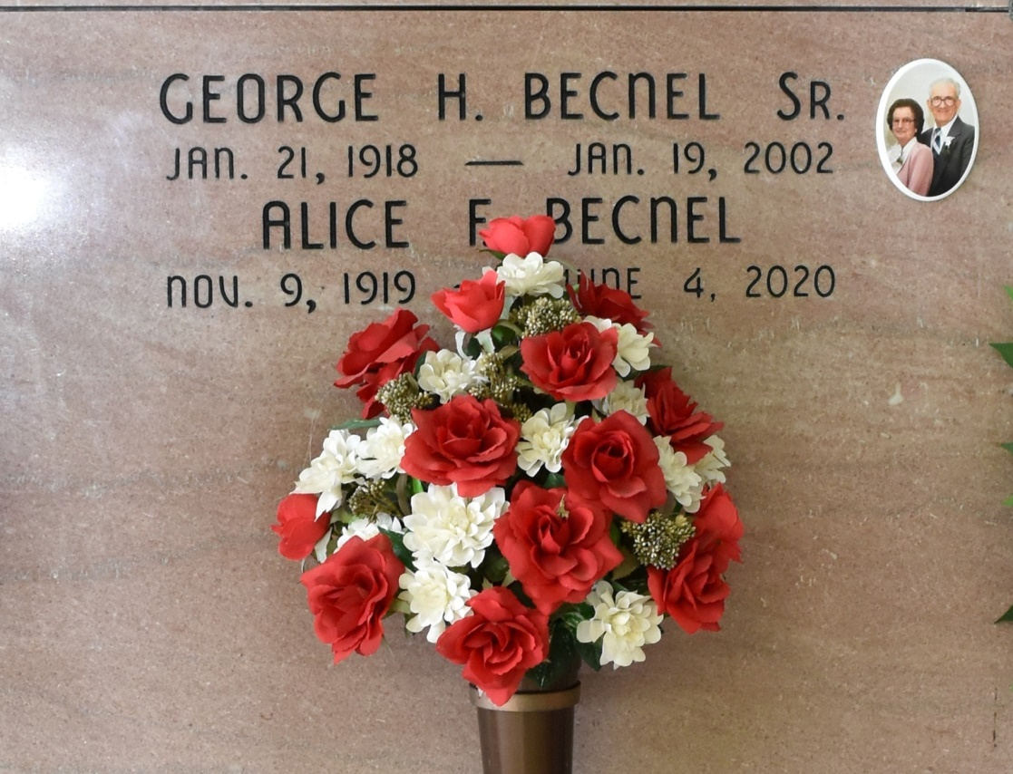

George "Blackie" Harold Becnel, Sr. died on Saturday, January 19, 2002 at Thibodaux Regional Medical Center. Beloved husband of Alice Falgoust Becnel. Father of Ralph Becnel (Henrietta), Cathleen Becnel Richard (Russell) and George Becnel, Jr. Son of the late Ulric Becnel and Therese Stein Becnel. Preceded in death by brothers: Clifford Sr., Thomas and Raymond Sr. Becnel and sister, Isabelle "Beo" Weber. Also survived by five grandchildren and one great-grandchild. Age 83 years. A native and resident of Vacherie, LA. He was an employee of Avondale Shipyards for 33 years. Relatives and friends of the family are invited to attend the funeral services. A Mass of Christian Burial will be celebrated on Tuesday, January 22, 2002 at 10:00 a.m. at Our Lady of Peace Catholic Church, Vacherie, LA. Visitation from 6:00 until 9:00 p.m. on Monday, January 21st and from 8:00 a.m. until funeral time on Tuesday at Our Lady of Peace Catholic Church. Entombment following at Our Lady of Peace Mausoleum. THIBODAUX FUNERAL HOME in charge of arrangements.
Times-Picayune, The (New Orleans, LA) - Tuesday, January 22, 2002
Contributed by Jane Edson

