Gertrude (Becnel) Becnel
October 7, 1920 – August 23, 2007

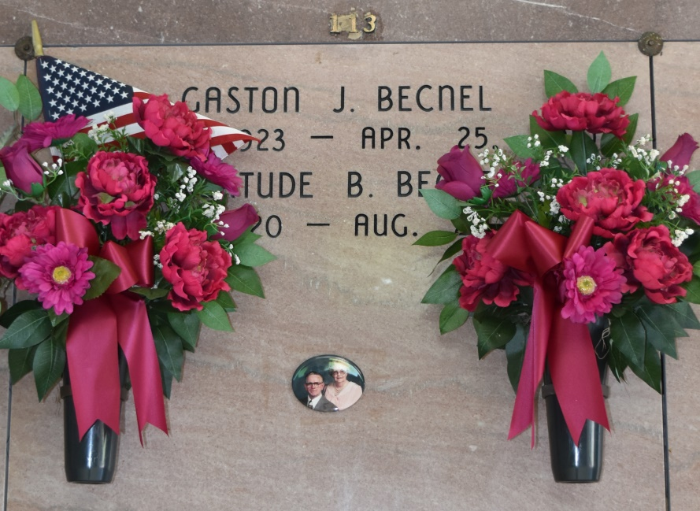

A resident and native of Vacherie, she died at 1:10 p.m. on Thursday, Aug. 23, 2007. She was 86, born on Oct. 7, 1920. Visitation at Our Lady of Peace Catholic Church in Vacherie on Monday, Aug. 27, from 8:30 a.m. until religious service at 11 a.m. She is survived by her husband, Gaston J. Becnel; three daughters, Betty L. Martinez and husband Gordon Sr., Mary L. Guedry and husband Julius, and Bernice L. Legendre and husband Michael Jr.; nine grandchildren, Kevin Martinez, Gordon Martinez Jr. and wife Roxanne, Kent Martinez and wife Michelle, and Darryl Martinez and wife Lourdes, Damian Martinez and wife Linda, Michele L. Anderson and husband John Jr., Chaffy Landry Sr., Nora L. McCarstle, and Troy Legendre and wife Danielle; 17 great-grandchildren and two great-great-grandchildren. She was preceded in death by her first husband, Numa Lassere; second husband, Louis St. Pierre; parents, Benjamin Sr. and Felicie Stein Becnel; five brothers, Benjamin Jr., Orestile, Stanislaus, Harris and Felix Becnel; four sisters, Theolene Becnel, Marguerite B. Torres, Yolande Becnel and Felice B. Reulet; and great-grandchild, Brayden Johnson. She was a caretaker for all her life. Her favorite hobby was playing bingo. Thibodaux Funeral Home of Thibodaux is in charge of arrangements.
Advocate, The (Baton Rouge, LA) - Saturday, August 25, 2007
Contributed by Jane Edson

