Jeanne Irene (Becnel) Becnel
July 30, 1919 – September 16, 2006

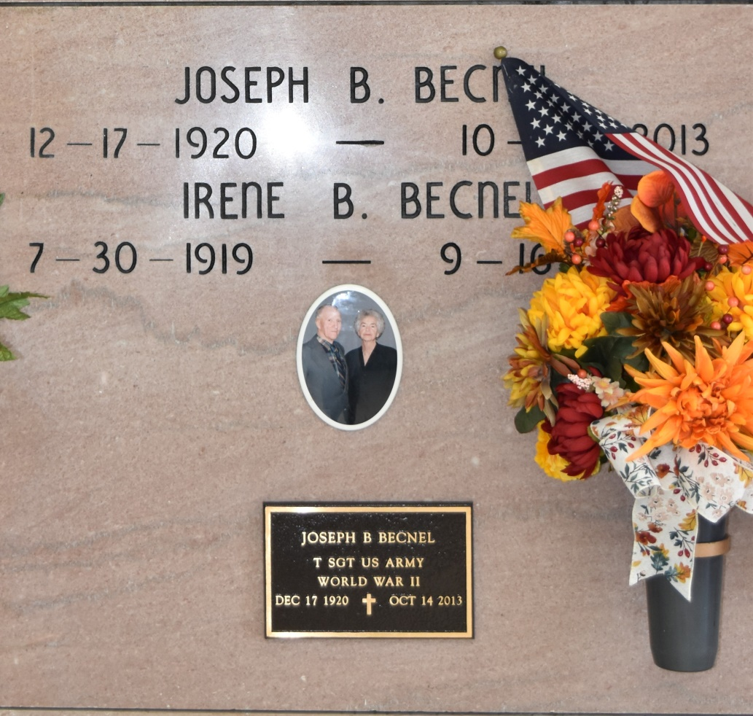

Jeanne "Irene" Becnel, a loving mother, grandmother and great-grandmother, 87 years of age, died Saturday, Sept. 16, 2006, at 8:45 a.m. in Thibodaux. She was a native and lifelong resident of Vacherie. She is survived by her husband, Joseph B. Becnel; three sons, Francis, Robert and Rene Becnel; daughter, Molly B. Levet; sister, Genevieve "Genny" Abadie; 11 grandchildren and seven great-grandchildren. She was preceded in death by her parents, Robert and Elucia Stein Becnel; brothers, Olan, Curtis "Frere," Glenn, Roland, Mark, Michel, Remie and Johnny Becnel; and a grandson, Jamin Becnel. Visitation will be at Our Lady of Peace Catholic Church, 13281 La. 644, Vacherie, on Tuesday, Sept. 19, from 8 a.m. until Mass of Christian Burial at 11 a.m. Interment will be in Our of Lady of Peace Cemetery, Vacherie. Rose Lynn Funeral Services, Lutcher, is in charge of arrangements.
Advocate, The (Baton Rouge, LA) - Sunday, September 17, 2006
Contributed by Jane Edson

