Joseph Bluebeck Becnel
December 17, 1920 – October 14, 2013

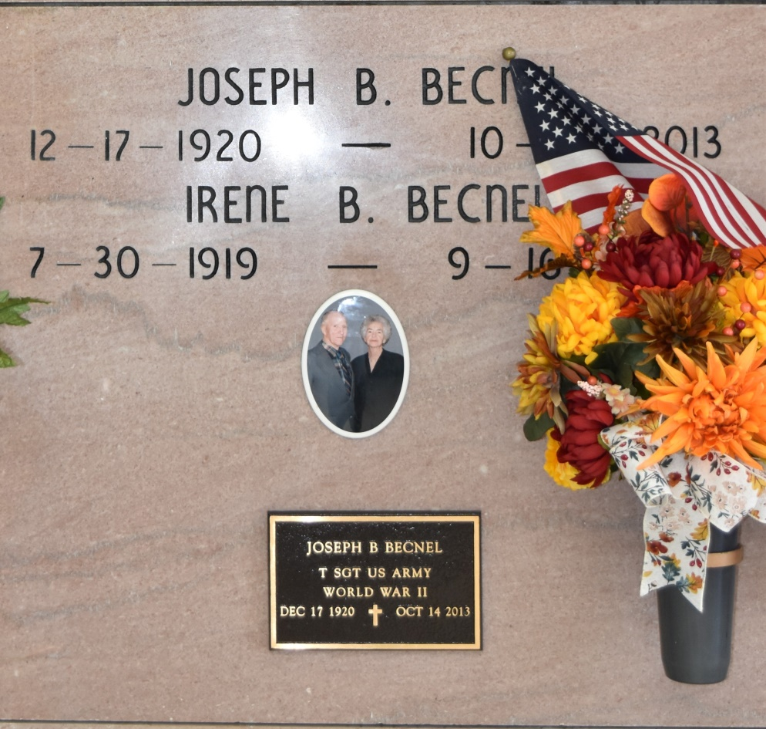

Joseph Bluebeck Becnel, was born on December 17, 1920 and passed away on October 14, 2013 at the age of 92. He was a Veteran of WWII and worked at Avondale Shipyard for 38 years. He will be greatly missed. Survived By Children Francis (Barbara) Becnel, Robert (Debbie) Becnel, Molly (Kenneth) Levet, and Rene (Evelyn) Becnel, 10 Grandchildren, 13 Great-grandchildren, Sister Jane B. Percle. Preceded in Death By Jeanne Irene Becnel, Spouse, Abel Becnel, Sr. and Margueritte Falgoust Becnel, Parents, Abel Becnel, Jr., Louis Becnel, Francois "Tony" Becnel, and Joseph Marcel Becnel, Brothers, Althe B. Rome, Delta B. Rodrigue, Anne Becnel, Thernica B. Becnel, Yvonne B. Percle, Marie B. Zeringue, Janet B. Folse, and Mabel B. Guillot, Sisters Jamin F. Becnel, Grandson. Visitation: Friday October 18, 2013, 8:00 a.m. - 10:45 a.m. at Our Lady of Peace Catholic Church. Mass of Christian Burial: Friday October 18, 2013, 11:00 a.m. at Our Lady of Peace Catholic Church; Burial: Our Lady of Peace Cemetery.
Unknown source

