Kirk Francis Becnel
June 2, 1954 – August 17, 2017

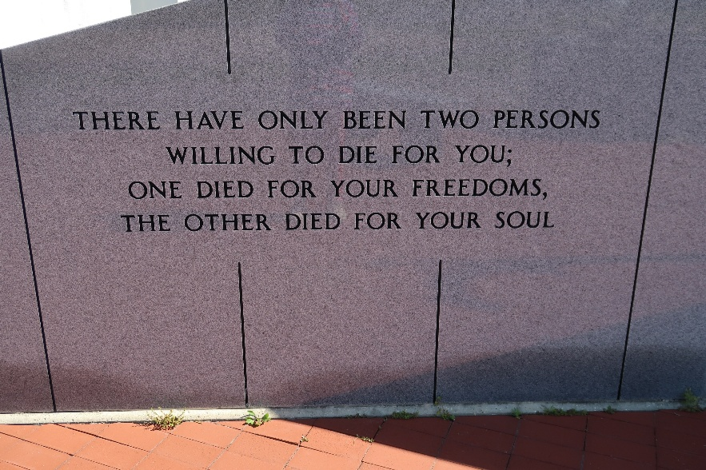

Kirk F. Becnel, 63, a native and resident of Vacherie, passed away on Wednesday, Aug. 23, 2017.
Visitation will be held at Our Lady of Peace Catholic Church on Monday, Aug. 28 from 9 a.m. until funeral time. A Mass of Christian Burial will be celebrated at 11 a.m., with burial to follow in the church cemetery.
Kirk is survived by his wife of 43 years, Susan G. Becnel; daughters, Tara Becnel Deslattes and husband David, Liza Becnel Gassen and husband, Brandon, and Kimberly Vaughn Lovell and husband, Jared; father, Joseph G. Becnel; nine grandchildren; one great-grandchild; brothers, Kenneth Becnel Sr. and wife, Marietta, Wilson Becnel and wife, Angel, and Bryan Becnel.
Kirk was preceded in death by his mother, Olga R. Becnel.
Kirk loved all his children, grandchildren and great-grandchild. He will be greatly missed by all he knew.
Samart-Mothe Funeral Home in charge of arrangements.

Houma Today, Terrebonne Parish, Louisiana
Aug. 25 to Aug. 26, 2017

