Larry Becnel
December 6, 1936 – November 14, 2023

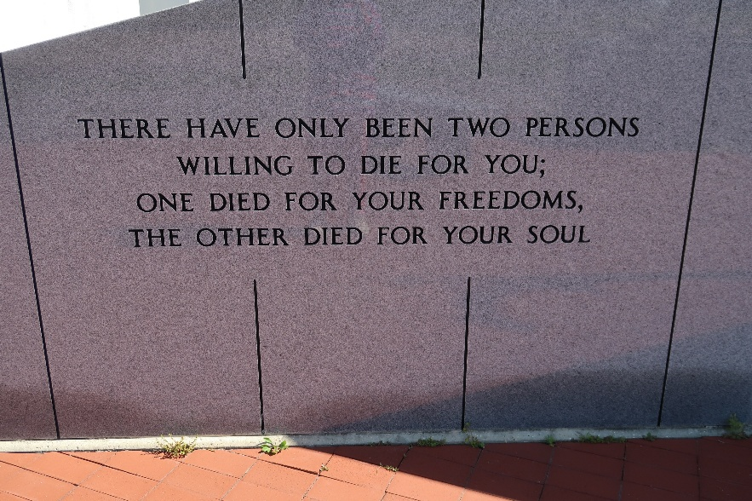

Larry "Rock" Becnel, 86, passed away surrounded by his loving family on Tuesday, November 14, 2023. Born December 6, 1936 he was a native and resident of Vacherie, Louisiana.
A visitation will be held on Friday, November 17, 2023 from 8:30 AM until service time at Our Lady of Peace Catholic Church. A Mass of Christian Burial will begin at 11:00 AM at the church with burial following in the church cemetery.
He is survived by his blessed 5 loving children, 9 loving grandchildren and 16 loving great grandchildren; Karen Becnel (Eulan) and her children, Darrin Champagne, Wendy Tardif; Roberta Boquet (Will) and their children, Michael Boquet, Michelle Saucier; Gayle Louque and her daughters, Lisa Duet, Jessica Balatico; Faron Becnel; Joanne Nassar (Vernon) and their children, Anthony and Harris Nassar, Theresa DuBois.
He is preceded in death by his loving wife and partner of 67 years; Ruth Josephine Rome Becnel; son, David Becnel; parents, Harris "Toot" Becnel and Josephine "Feen" Stein Becnel; father and mother in law, Victorin "Vic" Rome and Marie Althea Becnel Rome; son in law, C.J. Louque.

Ordoyne Funeral Home, Thibodaux, Louisiana

