Lea (Simon) Becnel
July 3, 1931 – December 1, 2013

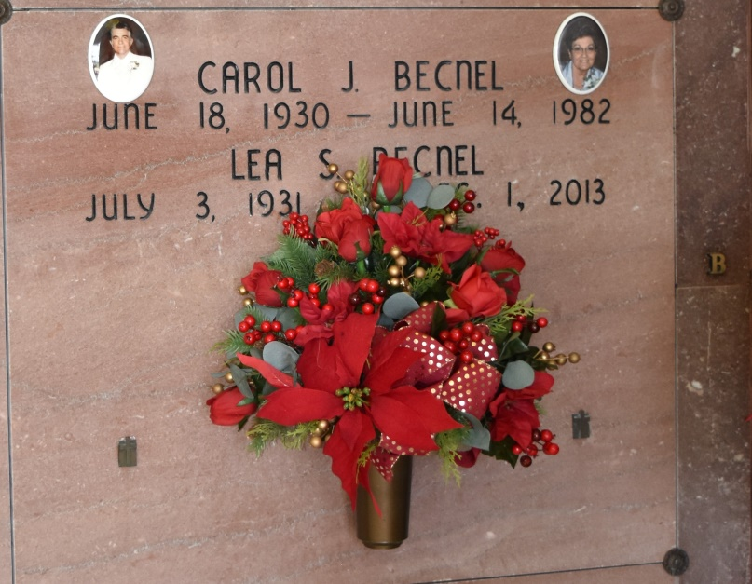

Lea Simon Becnel, 82, native and resident of Vacherie, Louisiana, passed away peacefully at her home on Sunday, December 1, 2013. She was born to the late Lionel and Annette Simon on July 3, 1931. Lea married the late Carol Becnel on February 6, 1949. Her true joy was her family. Survivors include her four children: Julie (Leslie) Hymel, Lona (Glenn) Waguespack, Keith (Dolly) Becnel, and Cindy (David) Hymel all of Vacherie; nine grandchildren, Ryan Hymel, Brady Becnel, Nicole Becnel, Andre´ Becnel, Rhett Waguespack, Katie Neiley, Christopher Hymel, Caroline Blanchard, Mallory Triche; three step-grandchildren, Ben Savoie, Eric Savoie, and Shelly Pohlel; eleven great grandchildren, and three step-great-grandchildren. She is also survived by her siblings Therese Cazenave, Lena Himel, Leo Simon, Mae Martinez, Ella (Callen) Dempster, Larry (Patsy) Simon, and Kate (Kenneth) Wood, along with sisters-in-law, Therese (Prudent) Steib and Irma Becnel. She was preceded in death by her brothers-in-law Robert Cazenave, U.J. Himel, Roland Martinez, and Clifford Becnel Jr, Steven Becnel; sisters in-law Shirley Simon and Virgie Becnel. Visitation at Our Lady of Peace Catholic Church, 13281 La. 643, Vacherie, on Thursday, December 5 from 7:30a.m. until Mass of Christian Burial at 11:30a.m. Entombment in the church mausoleum. Arrangements by Landry's Funeral Home, Thibodaux. In lieu of flowers, memorials can be directed to the Parkinson's Disease Foundation, 1359 Broadway Suite 1509, NY, NY 10018 or Children's Hospital of New Orleans 200 Henry Clay Ave, New Orleans, Louisiana 70118.
Advocate, The (Baton Rouge, LA) - Monday, December 2, 2013
Contributed by Jane Edson

