Leroy Joseph Becnel
February 2, 1938 – October 13, 2025

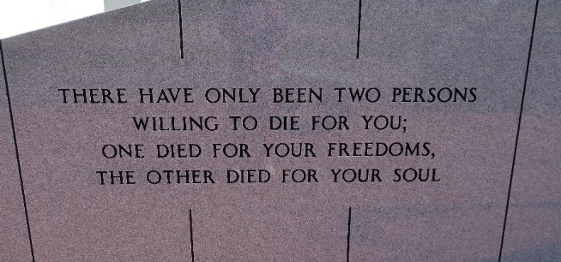

Leroy Joseph Becnel, 87, a native of Vacherie, Louisiana and resident of Thibodaux, Louisiana passed away on October 13, 2025.
A visitation will be held in his honor on Saturday, October 18, 2025, at Our Lady of Peace Catholic Church, Vacherie. Louisiana, from 10:30 am until the Mass of Christian Burial at 1:30 pm. Burial will follow in the church cemetery.
He is survived by wife, Ruth M. Becnel; son, Duane Becnel (Stephanie); daughters, Rachael Bourgeois (Larris), Angel Becnel (Willy); daughter-in-law, Terrie Becnel; grandchildren, Sandy (Matt), Mabel "Evie" (Trey), Evan (Janie), Leigh (Clay), Torri (Todd), Layne, Whitney, Trey; great-grandchildren, Lily, Canon, Sari, Emma, Abby, Anna, Parker, Paige, Clay Michael, Riley, Gabe, Henry, Elizabeth, Everleigh.
He was preceded in death by his son, Timothy "Scott" Becnel; parents, Amelus Becnel and Leone Stein Becnel; brothers, James Becnel and Louis Becnel; sister, Anna Lee Bourgeois; father-in-law, Valley Martinez; and mother-in-law, Francis "Popon" Martinez.
He was a devoted husband, loving father as well as a proud grandfather and great grandfather. He was known for compassion, generosity, and kindness to others. His guiding wisdom and presence will be missed by all.
In lieu of flowers, donations can be made to the Alzheimer's Foundation and St. Jude Children's Research Hospital.

Thibodaux Funeral Home, Inc., Terrebonne Parish, Louisiana

