Mary Agnes (Folse) Becnel
April 18, 1928 – March 25, 2023

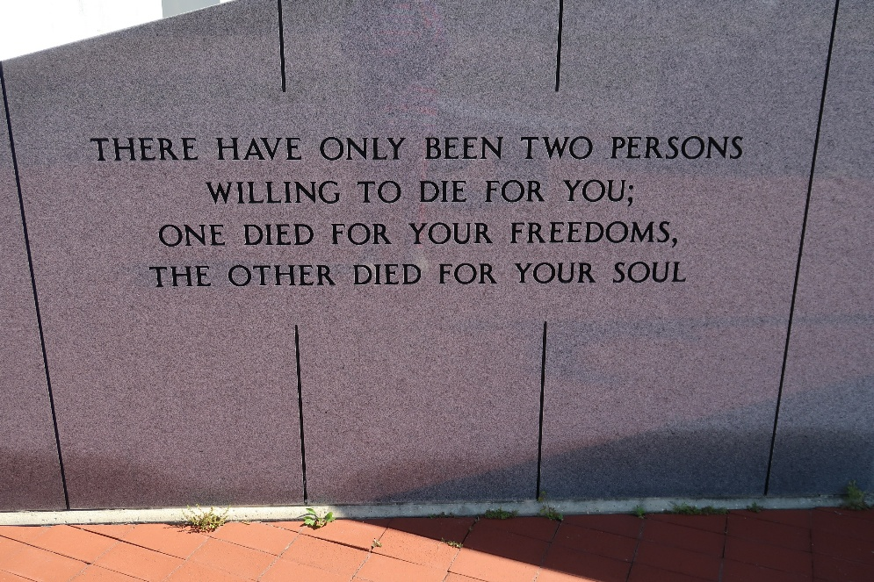

Mary Agnes Folse Becnel, born in Vacherie, Louisiana, on April 18, 1928, died at her home there the evening of March 25, 2023, a few weeks shy of her 95th birthday.
She was predeceased by her husband, Judge Charles Stanley Becnel; her parents, Marie Anne Falgoust and Eutrope Adam Folse; a daughter, Anne Marie B. Palazzolo; three sons, James Becnel, Bryon Joseph Becnel, and Charles Stanley Becnel, Jr.; a grandson, Christopher David Becnel; a great-grandson, Ty Martinez; a brother, Antoine A. Folse; and a sister, Bessie F. Rodrigue.
Mrs. Becnel is survived by a daughter, Adelaide Ann B. Bourgeois (and her spouse, Donald); three sons and their spouses, David Michael and Kathleen Becnel, Timothy Adam and Rachel Becnel, and Larry Charles Becnel and Carroll J. Rodrigue; another daughter-in-law, Geralyn H. Becnel; a sister-in-law (and lifelong friend), Aline L. Folse; a former daughter-in-law, Amelie D. Becnel; a former son-in-law, Mark Palazzolo; fourteen grandchildren; and twenty-two great-grandchildren.
Visitation will be at Our Lady of Peace Catholic Church in Vacherie starting at nine o'clock a.m. on March 30, 2023, followed by a Mass of Christian Burial at eleven o'clock a.m., celebrated by Father Matthew McCaughey. Burial will be in the church cemetery. Arrangements by Ordoyne Funeral Home, LLC, of Thibodaux.
The family respectfully asks that, if contemplating a memorial, you please consider the cemetery maintenance fund of Our Lady of Peace Church.

Legacy Remembers
Mar. 29, 2023

