Rose Mary (Brazan) Becnel
December 18, 1931 – March 9, 2019

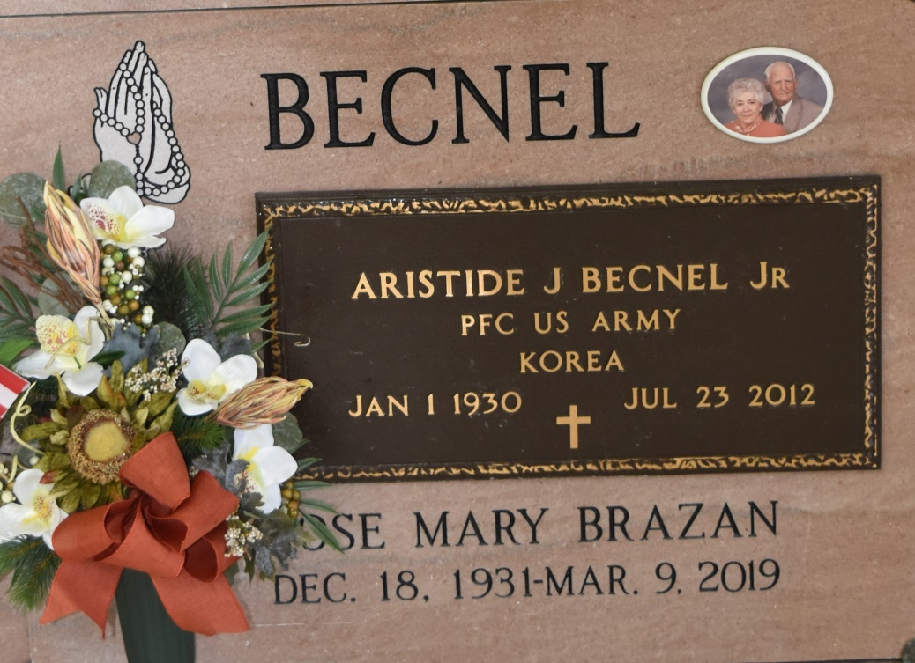

Rose Mary Brazen Becnel, 87, a native and resident of Vacherie, passed away on Saturday, March 9, 2019. A visitation will be held in her honor from 8:30 a.m. until the Mass of Christian Burial at 11 a.m. on Thursday, March 14, at Our Lady of Peace Catholic Church in Vacherie. Burial will follow in Our Lady of Peace Cemetery in Vacherie. She is survived by her son, Jody Becnel and wife, JoAnn; daughters, Pam Becnel Ordoyne, Gay Becnel Oncale, and Lynne Becnel Gillies; grandchildren, Joseph Becnel, Kevin Ordoyne, Erin Ordoyne Stewart, Cliff Oncale, and Colin Gillies; great-grandchildren, Mason and Ethan Stewart; and sisters, Anne Peterson, Essie Brazan, Patricia Bellanger, and Cheryl Hubbell. She was preceded in death by her loving husband, Aristide Joseph Becnel Jr.; father, Louis Brazan; mother, Oline Lassere Brazan; brothers, Charles and Gaspard Brazan; and sister, Lydia Dufrene. The family would like to thank Thibodaux Healthcare Center and St. Catherine's Hospice for their care and compassion. Thibodaux Funeral Home Inc. is in charge of arrangements.
Published in Houma Today & The Daily Comet, Terrebonne Parish, LA
Mar. 12 to Mar. 13, 2019

