Ruby Edith (Haydel) Becnel
February 9, 1929 – October 7, 2000

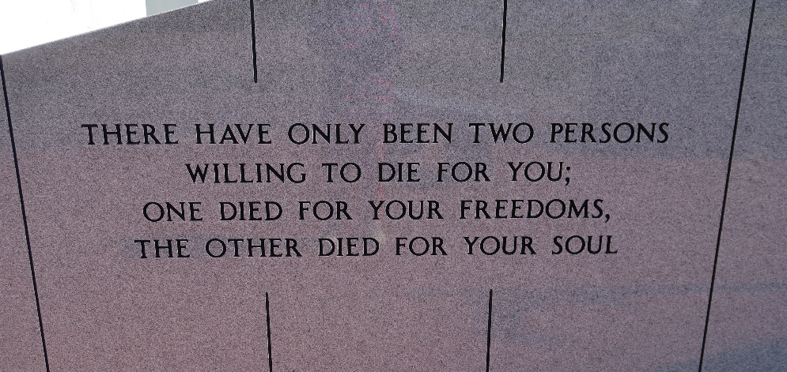

Ruby E. Becnel on Saturday, October 7, 2000.
Daughter of the late Dalton and Priscilla Haydel. Wife of the late Albert J. Becnel, St. Mother of Albert J., Jr. and Kerry M. Becnel, Gail Becnel Williams, Michelle Becnel Davis and Ursula T Becnel Brent. Sister of Theophile, Murray, Rogers S. and jerry Haydel, Oralee Ferchaud, Gilba Marshall, Mary Ann Burrell, Linda Pierce and the late Raymond Haydel. Also survived by 8 grandchildren, 1 great-grandchild, a host of in-laws, nieces, Nephews, other relatives and friends.
Relatives and friends of the family, also priest and parishioners of St. David Catholic Church are invited to attend the funeral services and Mass of Christian Burial on Wednesday, October 11, 2000, at 11:30 a.m. from Our Lady of Peace Cemetery, Vacherie, LA. Visitation on Wednesday at Boissiere-Labat Family Funeral Services, 1703 N. Claiborne Ave., N.O. LA from 8 AM until 10:00 AM.

Boissiere-Labat Family Funeral Services, New Orleans, Louisiana

