Ruth Josephine (Rome) Becnel
June 5, 1939 – April 2, 2023

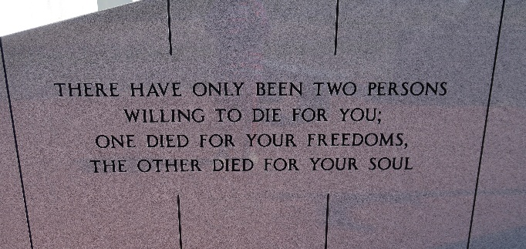

Ruth Josephine Rome Becnel, 83, passed away surrounded by her loving family on Sunday, April 2, 2023. Born June 05, 1939, she was a native and resident of Vacherie, Louisiana.
A visitation will be held on Wednesday, April 5, 2023 from 10:00 AM until service time at Our Lady of Peace Catholic Church. A Mass of Christian Burial will begin at 12:00 PM at the church, officiated by Father Matthew McCaughey. Burial will follow in the church cemetery.
She is survived by her loving husband and partner of 67 years, Larry "Rock" Becnel; blessed by 6 loving children, 9 loving grandchildren and 15 loving great grandchildren and one on the way; Karen Becnel (Eulan) and her children, Darrin Champagne, Wendy Tardif; Roberta Boquet (Will) and their children, Michael Boquet, Michelle Saucier; Gayle Louque and her daughters, Lisa Duet, Jessica Balatico; Faron Becnel; Joanne Nassar (Vernon) and their children, Anthony and Harris Nassar, Theresa DuBois.
She is preceded in death by her son, David Becnel, parents, Victorin "Vic" Rome and Marie Althea Becnel Rome; father and mother in law, Harris "Toot" Becnel and Josephine "Feen" Becnel; son in law, C.J. Louque; brother, V.J. Rome; and sisters, Margaret Cortez and Therese Falgoust.

Ordoyne Funeral Home, Thibodaux, Louisiana

