Steven J. Becnel
April 14, 1938 – October 15, 1997

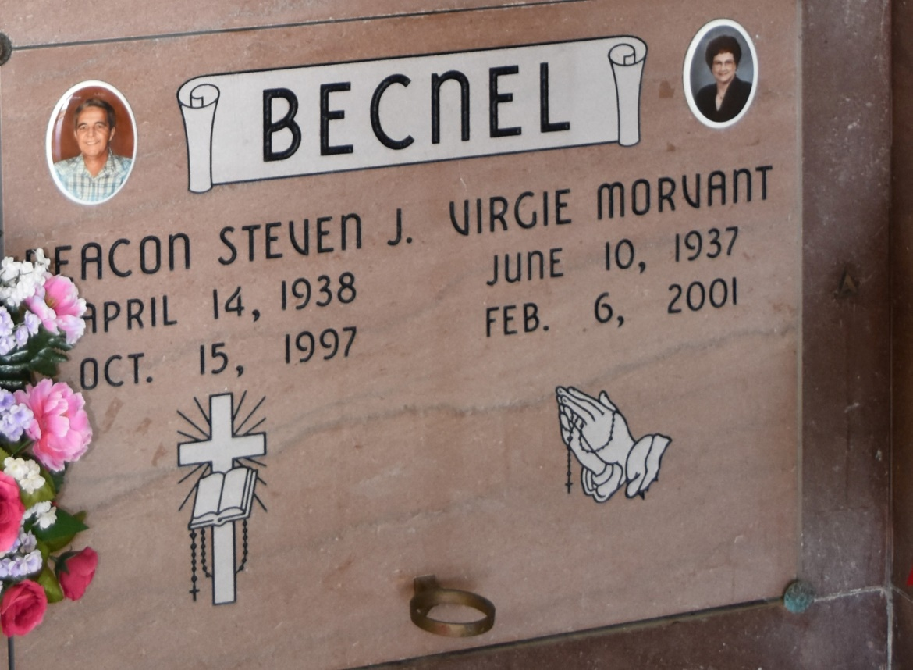

Mass of Christian was celebrated at Our Lady of Peace Catholic Church in Vacherie for Steven J. Becnel, 59, a native and resident of Vacherie, who died at 4:40 p.m. Oct 15, 1997. Entombment was in the church cemetery. He was the husband of Virgie Morvant Becnel, father of Matthew Becnel and Veronica B. Folse, brother of Clifford Becnel, Jr., and Marie Therese Steib. He was also survived by four grandchildren. He was preceded in death by his parents, Clifford and Henrietta Steib Becnel; a daughter, Cornelia Becnel; and a brother, Carol Becnel. He was a deacon at Our Lady of Peace.
Extracted from obituary at Thibodaux Funeral Home (LA)

