Tina (Granier) Becnel
January 30, 1951 – September 30, 2021

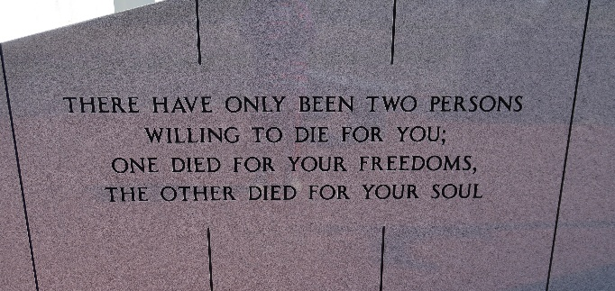

Tina Granier Becnel, 70, died Thursday, September 30, 2021. Born January 30, 1951, she was a native and resident of Vacherie, LA.
A visitation will be held on Thursday, October 7, 2021 from 9:00 am until service time at Our Lady of Peace Catholic Church. A Memorial Mass will begin at 11:00 AM at the church with burial following in the church cemetery.
She is survived by her son, Shane M. Becnel (Amy); daughter, Courtney Becnel Houck (Patrick); grandchildren, Tristan Becnel, Meah Becnel, Leland Becnel, Aria Becnel, Hunter Houck; brothers, Herman Granier, Jr. (Barbara), Morton Granier (Geraldine), Clayton Granier (Veronica).
She is preceded in death by her husband, Kenneth Becnel; parents, Herman Joseph Granier, Sr. and Lydia Falgoust Granier.
Tina was born raised and lived in Vacherie all of her life. She was also a woman of the world having traveled to many states in the US such as Texas, New York, and California as well as the far reaches of Japan and Australia. Tina was a woman of many talents having owned a Daiquiri shop and bakery, also a great cook and artist, she loved her casinos and was a great card player. Tina lived a full life, full of love, full of family, and full of community.

Ordoyne Funeral Home, Thibodaux, Louisiana

