Virgie (Morvant) Becnel
June 10, 1937 – February 6, 2001

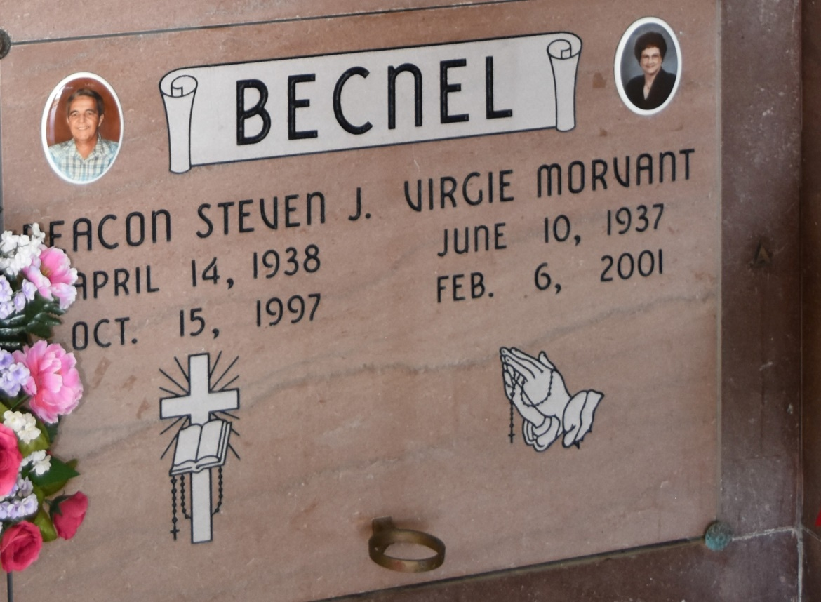

A resident of Vacherie, she died at 6:07 a.m. Tuesday, Feb. 6, 2001. She was 63, born June 10, 1937, in Thibodaux. Visiting at Our Lady of Peace Catholic Church, Vacherie, from 8 a.m. Thursday until Mass of Christian Burial at noon. Interment in church cemetery. Survived by a son, Matthew J. Becnel; a daughter, Veronica B. Folse; two brothers, Murphy and Earl Morvant; a sister, Rita M. Stein; and four grandchildren. Preceded in death by her husband, Steven J. Becnel; parents, Joseph and Odessa Trosclair Morvant; and a daughter, Cornelia M. Becnel.
Advocate, The (Baton Rouge, LA) – Wednesday, February 7, 2001
Contributed by Jane Edson
*****
VACHERIE - Virgie M. Becnel, 63, a native of Thibodaux and resident of Vacherie, died Feb. 6. She was the wife of the late Steven J. Becnel and mother of Veronica Folse and Matthew and the late Cornelia Becnel. She was also the daughter of the late Joseph and Odessa Trosclair Morvant and sister of Rita Stein and Murphy and Earl Morvant. She is also survived by four grandchildren. Services were Feb. 8 at Our Lady of Peace Catholic Church, South Vacherie, with interment at the church cemetery.
L'Observateur, LaPlace, LA - February 10, 2001

