Willie J. Becnel
October 24, 1935 – April 18, 2024

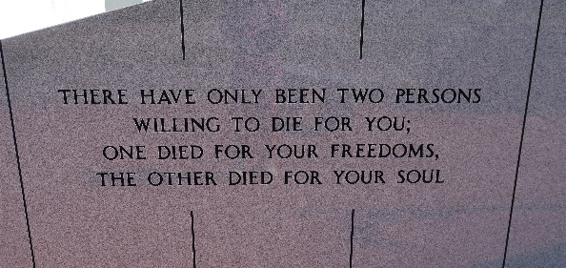

Willie J. Becnel, 88, a native of Vacherie, Louisiana and resident of Thibodaux, Louisiana passed away on April 18, 2024.
A visitation will be held in his honor on Saturday, April 20, 2024 at Our Lady of Peace Catholic Church, Vacherie, Louisiana from 9:00 am until the Mass of Christian Burial at 11:00 am. The burial will follow in Our Lady of Peace Cemetery, Vacherie, Louisiana.
He is survived by his wife of 40 years, Oris Caillet Becnel; sons, Gregory Becnel, Roger Becnel (Mary), Mitchell Becnel daughter, Cindy Becnel; stepson, Robert Dimm Jr. (Barth); stepdaughter, Theresa Tran (Van); brother, Milton Becnel (Fanilla); sister, Garnet Granier (Toby); one grandchild; six step-grandchildren; five great-grandchildren; eleven step-great-grandchild-ren.
He was preceded in death by his parents, Josue Becnel and Evelyn Chenier Becnel; brother, Gordon Becnel; stepgrandchild, Marianne Tran.
Willie loved life because of all of his great experiences, like being a U.S. Air Force radio transmission operator on a glacier in Alaska, becoming a machinist who owned his own machine shop and was part of a family team that created the MORBEC mag wheels, and traveling throughout the country with the love of his life, Oris. And nothing was more important to him than family and friends - he always had an open door, a laugh, or a shoulder as needed. He was beloved by so many and will be dearly missed.
Thibodaux Funeral Home, Inc. is in charge of arrangements.

The Advocate, Baton Rouge, Louisiana
Apr. 19 to Apr. 20, 2024

