Mary Beth (Bright) Blount
September 7, 1952 – October 19, 2006

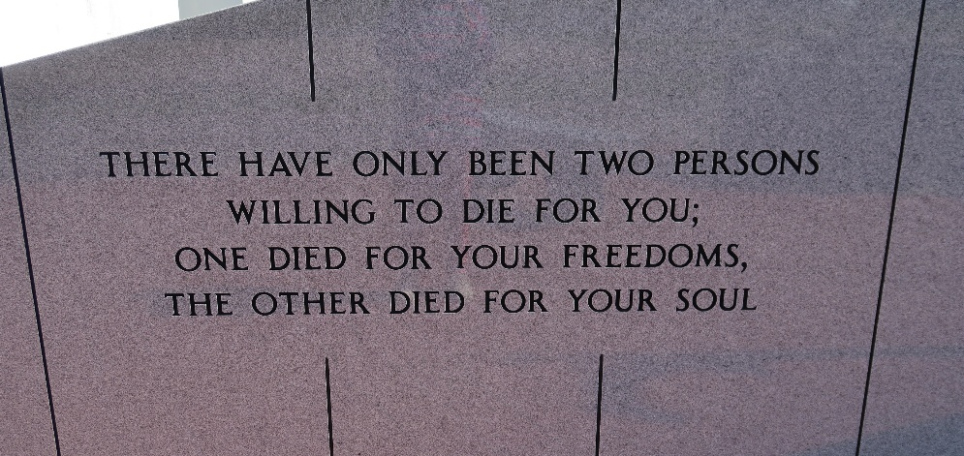

Mary ‘Beth’ Blount, of Vacherie, LA, resided in Gretna, died peacefully in her sleep of lung cancer on October 19, 2006.
She was preceded in death by her husband of 33 years, William Blount and her father, Elmer Bright. Beth is survived by her mother and her stepfather Adeline and A.P. Merkle. Her two children, Tasha Sheets and Joshua Blount, and one grandchild, Dominick Sheets. She is also survived by two sisters, Brenda Keller and Kathleen ""Kitty'' Dufrene, and a host of nieces and nephews. Beth was a beloved mother, wife, and friend.
Relatives and friends of the family are invited to attend a wake in the parlor of Mothe Funeral Home, 2100 Westbank Expressway, Harvey, LA on Tuesday, Oct. 24, 2006 from 9:00 AM until 11:30 AM followed by a funeral mass celebrated at Our Lady of Peace Catholic Church in Vacherie, LA at 1:00 PM. Interment Our Lady of Peace Cemetery, Vacherie, LA.
The family of Beth Blount would like to thank Albert Bairnsfather, Denise Thompson, Anne Garcia, Donna Moore, and the Poirrier family for all their help and patience during this time.

The Times-Picayune, New Orleans, Louisiana
October 22, 2006

