Reuben J. Bodin Jr.
May 6, 1943 – March 9, 2021

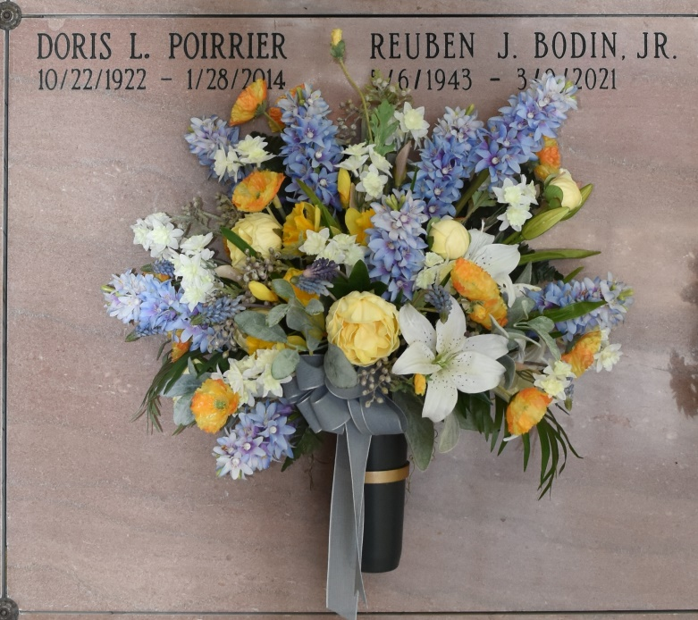

Reuben Bodin Jr., a native and resident of Vacherie, Louisiana passed away on Tuesday, March 9, 2021 at the age of 77.
A visitation will be held at Rose Lynn Funeral Home, Lutcher, Louisiana, Wednesday, March 17, 2021 from 10:00 A.M. to noon. A Mass of Christian Burial will begin at 1 PM at St. Philip Catholic Church, Vacherie, Louisiana. Interment will follow in Our Lady of Peace Mausoleum in Vacherie, LA. He had been a Knights of Columbus member for over 50 years.
He is survived by his wife of 56 years, Phyllis Poirrier Bodin; children, Adam Bodin (Dana), Allyson O’Connor (Sean), Peter Bodin (Stephanie), and Ian Bodin (Lee); grandchildren, Natalie (Bryan), Isabella (Kody), Alexis, Nicholas, Mallory, Chase, Reid, Dane, and Beck; great-grandchildren, Myla and Karson; and sisters, Deanna Shively, Janice Rubero (Paul), and Elaine Bond.
He is preceded in death by his parents, Elia and Reuben Bodin Sr.; and brother-in-law, Tommy Bond.
Reuben graduated from St. James High School in 1961 after an outstanding high school career in athletics. He received an athletic scholarship to the University of Southwestern Louisiana and graduated in 1966 with a BS in BA.
He served the community of Vacherie as the owner of Bodin’s IGA Supermarket for 38 years.
Reuben was an avid sportsman. He loved the outdoors, spending time with friends, family, hunting, fishing and attending his grandkids sporting events were his favorite.
Rose Lynn Funeral Services has been entrusted with handling his arrangements.

Rose Lynn Funeral Home, Lutcher, LA
May 21, 2022.

