Magnet (Scioneaux) Borne
November 10, 1903 – May 23, 1994

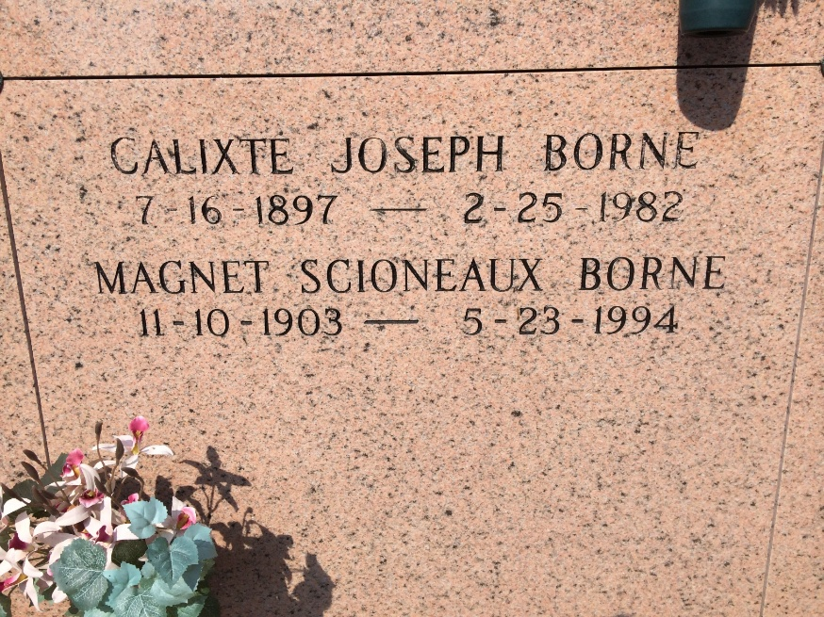
Photo by Kerry Keller

A Mass of Christian Burial will be celebrated at 4 p.m. today at St. James Catholic Church in St. James for Magnet Scioneaux Borne, 90, a native of Vacherie and resident of Thibodaux, who died at 7:25 a.m. Monday 23. Visitation will be 2 to 3:45 p.m. today at the church. A religious service will be at 3:45 p.m. at the church. Burial will be in Our Lady of Peace Cemetery in Vacherie.

She was preceded in death by her husband, Calixte Borne; parents, Rene and Marie Oubre Scioneaux; five brothers, Anyson, Armand, Wilson, Alexson and Ursin Scioneaux; and a sister, Lena Simon.

Thibodaux Funeral Home is in charge of arrangements.

Unknown source

