Roy Stephen Borne
November 23, 1938 – November 4, 2019

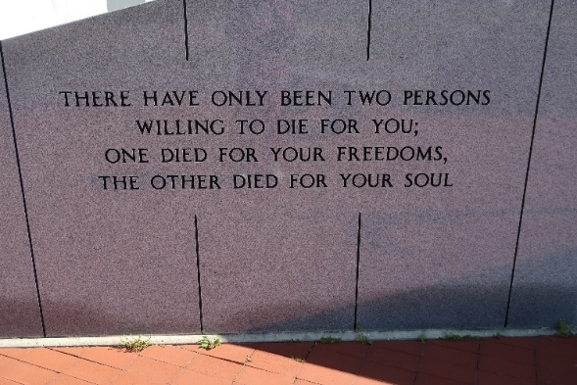

Roy "Chuckie" Stephen Borne, age 80, a native of Lucy, La., and resident of Vacherie, passed away on Monday, Nov. 4, 2019, at the Southeast Louisiana War Veterans Home in Reserve, La., following the three and a half year battle with heart complications and Alzheimer's.
A visitation will be held in his honor from 8 a.m. until the military memorial service at 11 a.m. on Monday, Nov. 11, at Our Lady of Peace Catholic Church in Vacherie. Burial will follow in the church cemetery.
He is survived by his loving wife of 57 years, Sylvia Folse Borne; daughter, Stephanie Collins (Emile); grandson, Lee Schexnayder; granddaughters, Anna and Andrea Borne; great-grandson, Maddux Schexnayder; brothers, Gerald Borne (Peggy) and Larry Borne (Mary); sister, Sallie Rose; in-laws, Danny Folse (Pat), Alfred Folse (Dolores), Evelyn Wood (Greg), Agnes Rodrigue (Donald), Kat Rodrigue (K.J.), Jeanne Waguespack (Anthony), Helen Waguespack (Rocky), Nathan Folse (Andrea), Francis Folse (Veronica), and Judy Folse; godchildren, Chris Tregre, Dawn Folse Allemand, and Gerald Borne Jr.; and numerous nieces and nephews.
He was preceded in death by his son, Stephan Borne; grandson, Lorne Schexnayder Jr.; parents, Roy and Stephanie Borne; brother, Michael Borne; and sisters, Audrey Dufrene (V.J.) and Patricia Cazes; in-laws, Daniel Sr. and Jeanne Folse; brother-in-law, Stanley Folse; and godparents, Lee Borne and Inez Hymel.
He was a 1957 graduate of Edgard High School where he graduated with honors and played football and baseball. He then served in the United States Army from 1957 until 1963. He was one of the original 43 employees hired at Occidental Chemical in Taft, where he retired after 38 years. Roy enjoyed spending time with family and gardening. He was an avid outdoorsman who raised beagles and was the member of the Pelican State Beagle Club, participating in multiple field trials and belonged to several hunting clubs.
Thibodaux Funeral Home Inc. is in charge of arrangements.
Houma Today & The Daily Comet, Terrebonne Parish, Louisiana
Nov. 7 to Nov. 8, 2019

